TRADE FAIR PRE-REPORT FOR PUBLICATION

GEZE at fensterbau frontale 2016

16 - 19/03/2016 NürnbergMesse, Hall 2, Booth 2-424

Leonberg, 10 February 2016

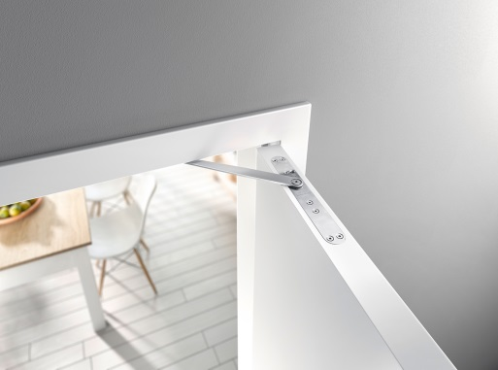
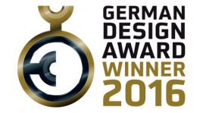
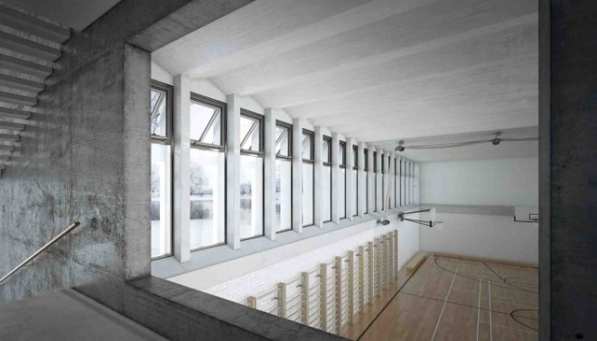
All photos: GEZE GmbH
The new award-winning GEZE ActiveStop door damper can be attractively integrated brings a new level of convenience to the home environment.
The Powerchain chain drive for large and heavy windows within
an RWA system solution. The IQ windowdrives are equipped with
a KNX interface.

GEZE. Convenience and security, naturally.
At FENSTERBAU FRONTALE, GEZE is presenting innovative solutions which significantly improve and facilitate living and working in modern buildings as well as make them safer, focusing the Professional, Living and Service fields.
These include new interface solutions for integrating products into the communication standards used for premises and building systems technology (KNX and BACnet), as well as window technology, automatic door systems, door technology, and services (e.g. software for improving planning certainty).

Professional Solutions: clever forward-looking solutions for smart buildings
GEZE is showcasing two interface modules for intelligent building networking which can be easily integrated into the KNX and BACnet protocols:
In the window technology field, the IQ box KNX interface module enables controlled, natural ventilation and direct incorporation of the GEZE IQ windowdrives into KNX building systems. More detailed information about the window functions is of course also provided.
The new IO 420 interface module is the key to "smart buildings" because all the system components are interconnected within a network. This means that door systems, ventilation technology and RWA (smoke and heat extraction systems) as well as safety systems (e.g. emergency exit control systems) can be integrated into the building management system via the BACnet worldwide open communications protocol.

In the door technology field, GEZE is presenting two solutions with outstanding safety features:

A new version of the Powerturn automatic swing door drive for especially large and heavy doors is being presented as part of a system solution: in conjunction with systems and products such as the IQ lock AUT electronic motor lock, the TZ 320 escape door control system, and the FTV 320 escape door lock.

IST Systems (a GEZE subsidiary) has added the new A4000 vector electric strike to its product portfolio: its particular strengths include almost silent door opening as well as secure release of the lock latch even when under high preload – and without the need for additional electronics. The typical IST compact dimensions have been retained, which provides new design options and guarantees a high level of planning certainty.

Living Solutions: the perfect combination of strength, convenience and design
The highlight in the Living Solutions field is the GEZE ActiveStop door damper. It provides a much greater level of convenience and feeling of spaciousness. GEZE ActiveStop can stop doors gently, close them quietly, or hold them open with ease, and it can be set in an instant. It also fits into virtually any standard doors – providing a solution that's tailored to your needs and living space. One of the enhancements in the Living Solutions field is the expanded range of manual sliding door systems, such as the new Levolan 120 system. A discreet, straight-lined appearance, a modular structure, and the convenience of installation are its key features.

Service Solutions: the right solution for every requirement
Whether it's in the form of quick installation or practical planning assistance: GEZE specialises in providing tailored services. The focus in this field is on overall support for building management systems within a project – ranging from installation, maintenance and repair to the modernisation of existing systems. The benefits for planners include new software solutions which ensure convenient and reliable planning right from the initial design phase.

Press contact:  Julia Graf  Tel.: +49 (0) 7152 203-505  j.graf@geze.com  Fax: +49 (0) 7152 203-237 | GEZE GmbH  Reinhold-Vöster-Str. 21-29  D-71229 Leonberg  www.geze.com

About GEZE
The GEZE brand stands for innovation and for top quality products, processes and services. GEZE is one of the leaders in the global market and it is a reliable partner worldwide for door, window and safety technology products and systems. No matter what the requirements of a building are – GEZE implements optimum solutions and combines functionality and security with comfort and design. GEZE door closers open up numerous technical and visual possibilities. Every day, millions of people go through doors equipped with the overhead door closers from the TS 5000 series and enjoy the comfort of automatic door systems, e.g. the Slimdrive range. Barrier free door and window systems provide greater comfort, not only for people with restricted mobility. The glass systems and fitting solutions for the attractively designed sliding systems are the ultimate in design aesthetics. GEZE also offers a wide product range in the field of window and ventilation technology. Complete "intelligent" smoke and heat extraction solutions (RWA) and a comprehensive selection of door systems for RWA air supply solutions are also available for preventive fire protection. GEZE's safety technology includes escape and rescue route solutions, lock technology, and access control systems. The GEZE building management system provides an overview of a building's entire technical facilities. With its systems expertise, GEZE creates coordinated system solutions which combine individual functional and safety requirements in one intelligent system. GEZE product solutions have received numerous awards and can be found in renowned structures all over the world. The company has a global presence with 31 subsidiaries, 27 of which are outside Germany, a flexible and highly efficient sales and service network, and almost 2,700 employees. In the 2014/2015 fiscal year, GEZE achieved a turnover of over 366 million euros. www.geze.com

