**TRADE FAIR PREVIEW FOR PUBLICATION**

**GEZE at Light + building 2016 – world leading trade fair for lighting and building technology**

**13 - 18.03.2016 Messe Frankfurt, Frankfurt/Main, Hall 9, Booth D21**



Leonberg, 02 February 2016

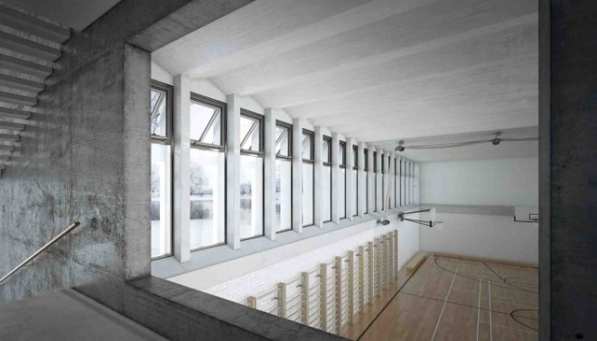

Photos: GEZE GmbH

|  |  |
| --- | --- |
| More security and convenience: the window drives of the  IQ window drive series can be integrated with the new interface module IQ box KNX in KNX bus systems. | Key to Smart Buildings: The new interface module IO 420 integrates GEZE solutions in network solutions with BACnet |

GEZE. System integration made easy!

With a focus on building and room automation Light + Building GEZE will be presenting innovative solutions that deliver overall improvements to living and working in modern, intelligent buildings. They make buildings more comfortable, increase security in the building, reduce energy consumption and create new visual possibilities. Automated and networked building functions with GEZE solutions offer beneficial advantages to users, building operators, investors, architects and specialist planners as well as the electrical sector (trade, industry and retail).

Smart Buildings: Networked solutions are defining the future

The highlights of the trade fair presentation are the new interface solutions for the integration of GEZE products in standardised worldwide open communication protocols for home and building systems technology (KNX and BACnet).

In window technology, the **interface module IQ box KNX** enables the visualisation, command and control of the intelligent window drives in the IQ window drive series in a building equipped with the KNX bus system. It even enables direct integration into the KNX bus system drives to control natural ventilation. For maximum efficiency and security in building operations, the new module in the KNX bus also makes addition information available to the window functions.

The **interface module IO 420** is the key to 'Smart Buildings' – all system components can be networked with each other via the BACnet communication protocol. This means that GEZE door systems, door technology such as e.g. hold-open systems, ventilation technology, smoke and heat extraction systems (RWA) and safety systems (e.g. emergency exit controls) can be integrated into the building management system via the open standard.

High traffic entrance doors: Electric strikes for convenience, security and design

GEZE is demonstrating its expertise and comprehensive range of electric strike systems with the extended product range from GEZE's subsidiary IST Systems:

The particular strengths of the new **A4000 vector electric strikes** include almost silent door opening as well as secure release of the lock latch even when under high preload – and without the need for additional electronics. The typically small IST dimensions guarantee new design possibilities and a high level of planning security – benefits that excite the electrical trade as much as they do door manufacturers and installation engineers, architects and professional planners.