Reference report for publication

From the Orient Express to the “Wolkenspange” building
GEZE door comfort with style in the modernised Vienna West Station

Leonberg, 18 June 2018
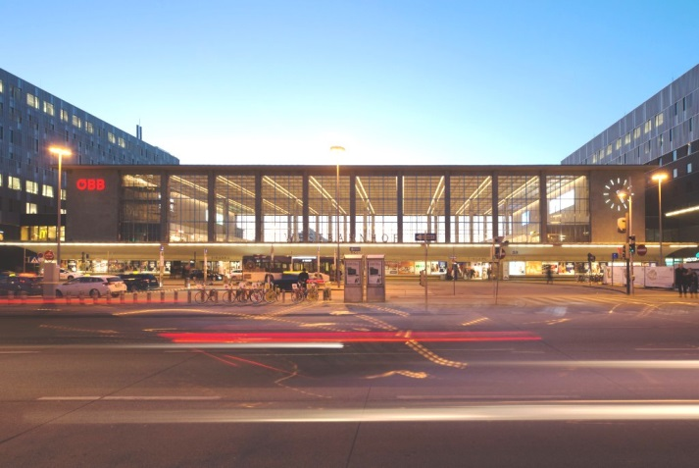
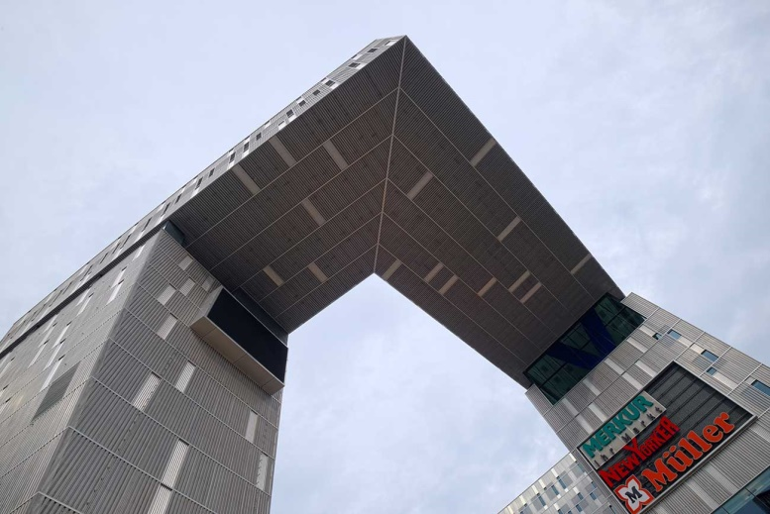

Picture credit: Shutterstock Photo: Sigrid Rauchdobler for GEZE GmbH
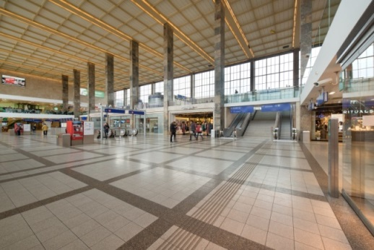
Automatic sliding and swing door systems:
Ease of access and safety for passengers,
reliability for large crowds of people,
can be integrated into the building management system

Manual sliding wall systems (MSW):
Inviting open shopping environment

Various door closer systems on manual doors:
Essential for preventive fire protection

Photo: Sigrid Rauchdobler for GEZE GmbH

Since Wien Westbahnhof (Vienna West Station) was modernised, the “Wolkenspange” building has been its distinguishing feature. BahnhofCity Wien West also includes a hotel, a shopping centre and an office block. The building parts are connected by a framework structure made of steel girders (known as the “Wolkenspange” [Buckle in the clouds]). The architectural statement of Viennese architects Neumann & Steiner weighs over 430 tonnes, and stands out from the large, bright and renovated station concourse, which dates back to the 1950s.

Anyone crossing the station concourse today, heading past the shops to the platforms, will find it hard to imagine how much nostalgia is hidden there. When it opened in 1858, the Empress Elisabeth Station – as it was known – was the central transport hub to western, southern and south-eastern Europe. The route taken by Railjets today was previously that of the Orient Express, which brought glamour to Vienna. The conclusion of the international history of the legendary Paris - Istanbul line, which started in 1883 with the Orient Express and ended in 2009, did not stop the station from developing. It is now a hub for regional connections, and traffic management and travel comfort have been steadily improved.

Passenger comfort thanks to GEZE automatic door comfort
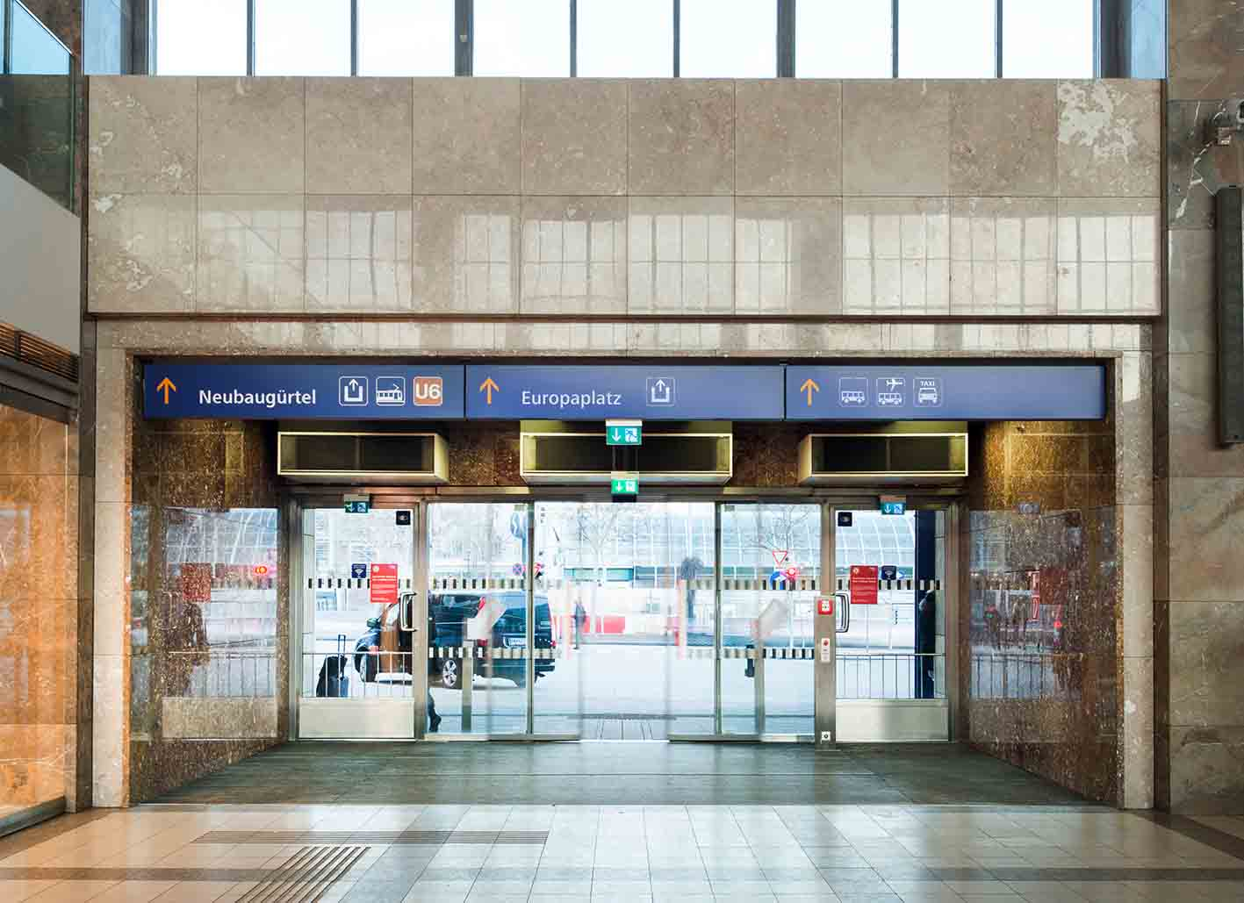
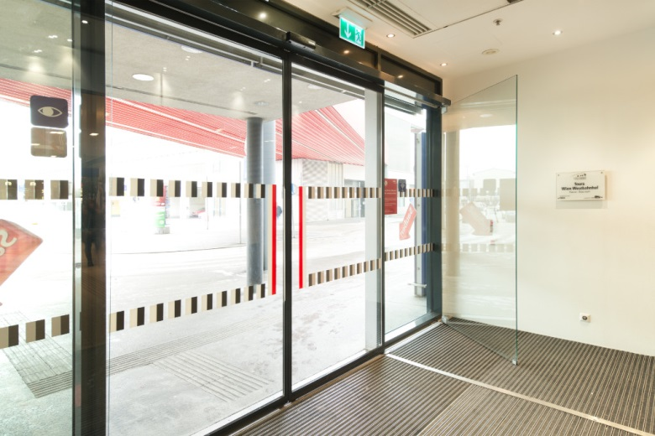

Photos: Sigrid Rauchdobler for GEZE GmbH

In the modern travel complex, around thirty automatic sliding doors with drives from the Slimdrive range are in use. Whether they are façade doors in the wide and high entrances to the station concourse, on the shopping levels, in the hotel or the office block, Slimdrive sliding door systems ensure optical reduction. At just seven centimetres high, the drive systems have been discreetly integrated into the façade and interior areas. Generous passage clearance, slim door profiles and Slimdrive SL NT-FR sliding door systems in the emergency exit design ensure barrier-free ease of access, emergency exit protection, brightness and transparency. In the case of more restricted door opening widths on an emergency exit route, maximum possible opening widths were achieved thanks to 4-leaf automatic telescopic doors with Slimdrive SLT-FR drive variants. The “stacking” of the door leaves is not a problem with this solution.

These doors are intelligent
The subtle Slimdrive drive units conceal modern, intelligent control technology. The quiet, high-performance drives are almost unnoticeable and are well prepared for large crowds of people. Their hold-open time adapts to the usage frequency. If the stream of visitors is higher, the door leaves are automatically kept open for longer. The acceleration, hold-open time and opening and closing speeds can be set individually.

Need-oriented: the combination of swing door drive and door closer
In the office building, the combination of door drives and door closers is an ideal solution for large, heavy double-leaf doors, where it is mainly the active leaf that moves, and automatic operation means improved ease of access. Despite the different technology, the drive design of both door leaves is universal and discreet. The active leaf is fitted with a TSA 160 F-IS swing door drive, and the passive leaf with a manual TS 5000 door closer, because it is only opened when necessary. The drive housing also contains the closing sequence control required for fire protection doors. It guarantees that both door leaves are correctly closed again in a controlled way after access, e.g. by fleeing persons in case of danger.

Fit for the future: can be integrated into the building management system
The control of the Slimdrive and TSA drives makes the doors future-proof, since it enables system integration in the building management system. For example, the monitoring or adjustment of the door functions can be carried out remotely, thus increasing the efficiency of the building operation.

Shopping invitation: manual sliding wall systems

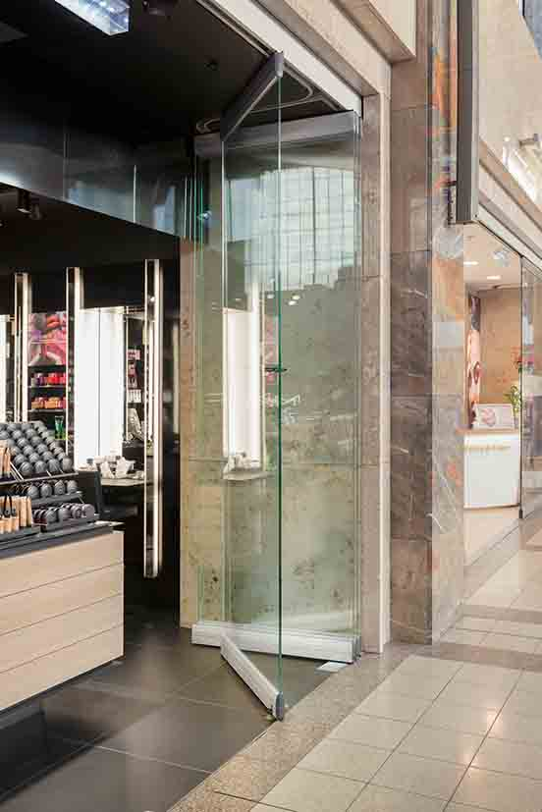
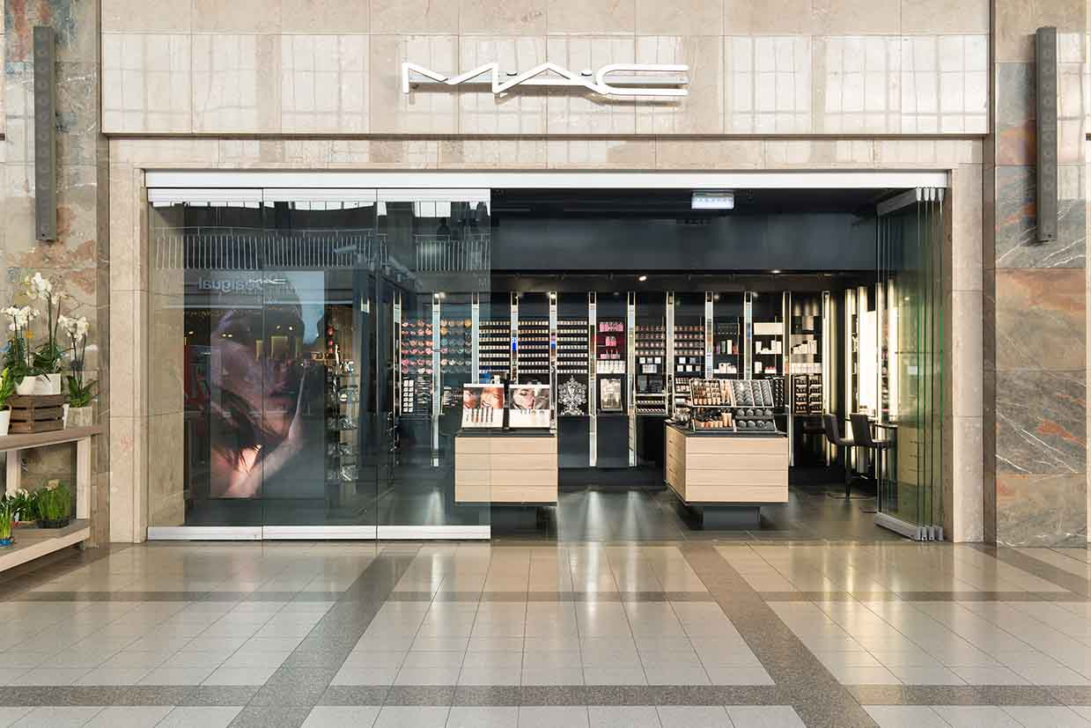

Photos: Sigrid Rauchdobler for GEZE GmbH

Photos: Sigrid Rauchdobler for GEZE GmbH

For an inviting and open atmosphere, manual sliding wall systems (MSW) are an essential feature in shopping malls. Shops and outdoor spaces are barrier-free and merge. To open the manual sliding wall system, the glass elements are simply inserted in to the lateral stacking area and are “stacked” without taking up too much space. Precision ball bearings in the roller carriage ensure that the large glass leaves run smoothly and quietly. Hardly any force is needed to insert the elements into the stacking area. This is possible due to the optimum curve technology in the rail branches and bends, as well as the guided roller carriages which move the glass elements easily and safely.

System elements with various GEZE MSW system functions enable a large number of combinations for every installation situation. With its stacking areas on the left and right sides, the design allows the shop front to be partially opened, which is particularly advantageous in the colder months. People can leave the shop when the MSW system is closed, thanks to a double-action door with a floor spring, which is positioned in the stacking area, and forms a secure fastener for the moveable glass partitioning wall.

Door closer technology for preventive fire protection
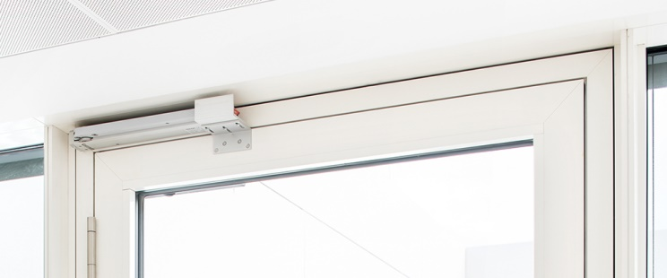
In the entire station complex, there are over one hundred manual single and double-leaf doors from the GEZE door closer range. They ensure the safe and reliable closing of doors that must always be kept closed and monitored, or at least in the event of a fire. Door closer systems in the office complex ensure controlled natural smoke and gas ventilation in the event of a fire, and safe closure in normal mode. K 600 retractable arm drives, also combined with TS 5000 door closers, serve as fresh air or air vent openings. In the event of a fire, the doors are automatically pushed open, and kept wide open so that fresh air can be supplied, and smoke and heat can escape.
Photo: Jürgen Pollak for GEZE GmbH

