REFERENCE REPORT FOR PUBLICATION

Leonberg, 03/05/2018

The ÖAMTC Mobility Centre in Vienna:

“Focus on the person" implemented with the latest technology from GEZE

The GEZE contribution to mobility and closeness in Vienna Erdberg:
- Project competence: Customised solutions in cooperation with everyone involved in the construction in order to improve operating processes – from handling visitor flows to optimum system catering in the cafeteria
- Look and design: Integration of systems for a universal aesthetics
      - Revolving doors: glass aesthetics in the façade
      - Barrier-free fire protection doors
      - Intelligent window systems for preventive fire protection (RWA)

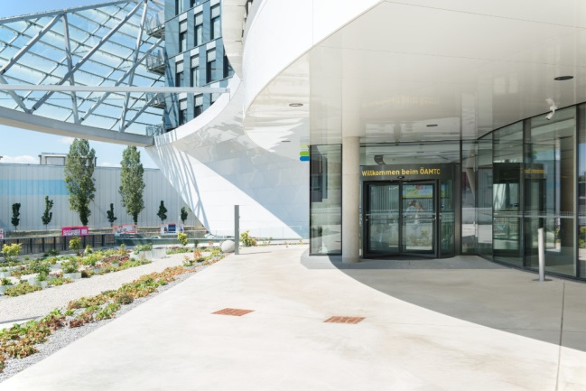
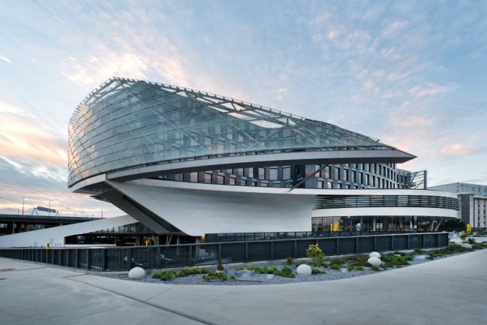

Photos: Sigrid Rauchdobler for GEZE GmbH

Mobility and speed are the inspiration behind the impressive new headquarters of the Austrian automotive association, the 'Automobil-, Motorrad- und Touringclub' (ÖAMTC). The 76-million euro new building was erected at one of Vienna's most important traffic axes, the South-East tangent of the city motorway A23. Mobility and speed are also associated with the services of a modern traffic club. They are experienced in the building everyday with efficiency and quick communication.

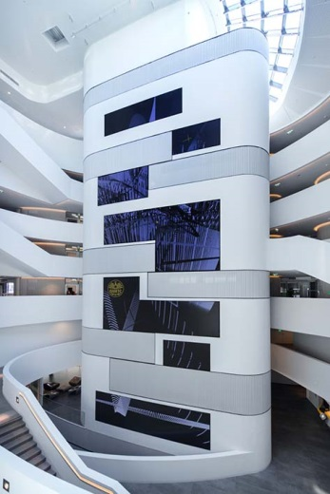
Transparent and open

The Vienna architects Pichler & Traupmann realised their idea in a curved, circular and star-shaped architecture with open and transparent room connections. If one wanted to, one could follow the technical tests on one's vehicle from a glass cockpit in the central shop and consultation area or directly from the waiting area. All the areas, from the counter and consultation zone, the testing hall and the back office area to the heliport are arranged along a vertical axis. The importance of the fast interaction and the exchange between the areas can be seen in the central, transparent atrium as well with its circular balustrades, which are offset to each other and stagger upwards.

Revolving doors: attention-getter and "pivot point" in the foyer
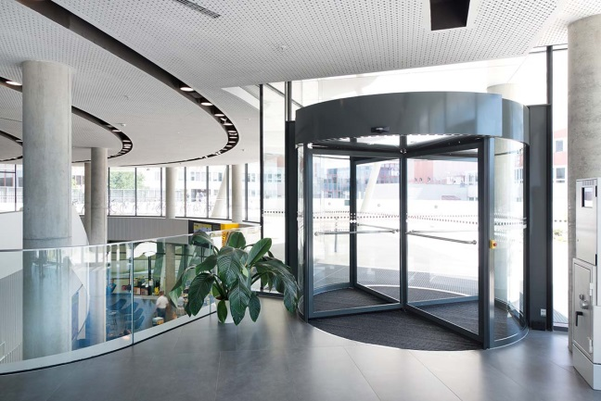

Automatic revolving door systems from the TSA 325 NT range

Photo: Sigrid Rauchdobler for GEZE GmbH

At the main and side entrances, revolving door systems connect the outside and inside and ensure the aesthetic consistency of the glass façade. The door with its fine-framed drum walls and leaves has an invitingly bright and transparent effect. The glass edges are covered by discreet aluminium profiles. The high-quality profile finish with rounded edges gives the leaves a hint of elegance.

Good climate in a quiet environment

Both open and closed, the outside and inside climate are separated by the revolving doors. Draughts stay "outside". The air curtain unit fitted in the ceiling canopy provides additional protection against incoming cold air. Thanks to the insulating effect of the revolving doors, the background noise of the motorway also stays outside – a welcome benefit because the entrances are situated on the first floor and at the same height as the carriageways.

A given: convenience and safety

The revolving doors are also an ideal solution for the natural and high level of convenience that should accompany the members, visitors and employees in their coming and going. The selected semi-automatic TSA 325 NT variant uses the automatic positioning device to reset the leaf to the starting position after entering in order to accept the next "passenger". The safety standards are high: contact with the closing edges triggers an emergency brake and prevents hands or objects getting trapped between drum walls and leaves. The automatic limiting of the revolving speed of the leaves guarantees safety when entering.

Fire protection and accessibility in one
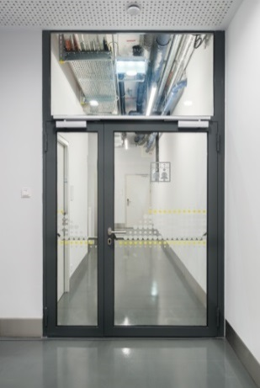

Modern door closing technology ensures the preventive fire protection for the barrier-free escape and rescue route doors on the floors, for example with door closers with free swing function of type TS 5000 EFS: the free swing function enables the doors to be opened with minimal pushing force in either the opening or closing direction when entering. The comfort hold-open function allows the doors to be locked in position at the end of the free swing area without closing in an uncontrolled manner or jamming in a partially closed position – if there is a draught for example. Automatic closing of the door in the case of fire is maintained. The doors close safely at any time when released. The door closers can be set variably up to the highest closing force EN 6 and can be used on single and double-leaf fire and smoke protection doors.

Barrier-free: fire protection doors with

free swing and comfort hold-open function with GEZE door closer technology

Photo: Sigrid Rauchdobler for GEZE GmbH

TS 5000 ISM door closers with free swing and comfort hold-open function guarantee the right door closing sequence for both leaves on the double leaf, also asymmetrical fire protection doors. The integrated closing sequence control holds the active leaf open until the passive leaves have closed to ensure a safe closing of the doors in case of fire. The TS 5000 E-ISM variant also includes an electrical hold-open function in the guide rail. The holding open of these doors can therefore be variably adjusted.

Fresh air guaranteed: automatic windows with "intelligent" drives

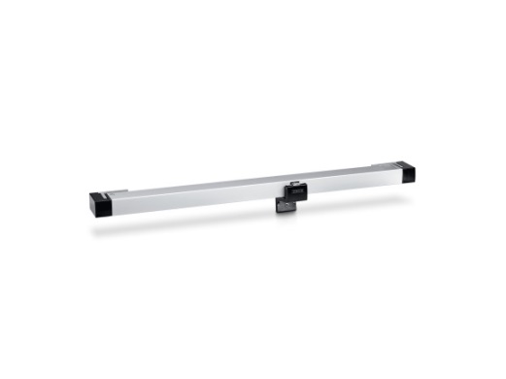
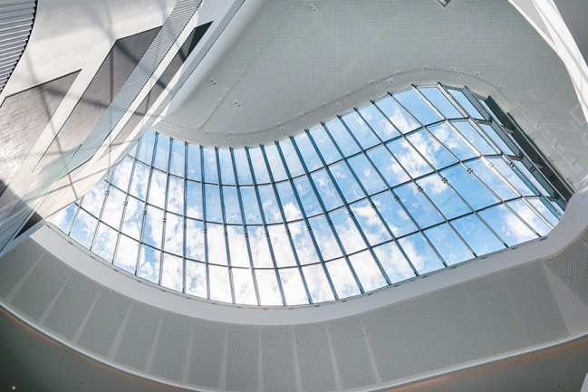
Keeping escape and rescue routes smoke-free so that everyone can reach safe areas as quickly as possible is the highest priority. The smoke and heat extraction systems (RWA) are useful twice in the testing hall: with their pulling power, they serve the reliable and safe smoke removal in case of fire as well as day-to-day ventilation. Powerful, but with a discreet look, Powerchain-Syncro chain drives open the large workshop windows, for example, with a stroke of up to 80 centimetres. In case of fire, the window is fully opened in less than 60 seconds. The integrated control unit makes the drives easy to combine and ensures the sequential and safe opening and closing of the windows as well as the synchronisation of up to three drives. The Powerchain drives from the GEZE IQ windowdrives series are "intelligent". They can be integrated into KNX building systems as direct bus participants for natural ventilation.

Discreet and powerful: intelligent window drives from

the IQ windowdrives series, e.g. the "strong" Powerchain chain drive for large windows, also in the roof

Photos: top: Sigrid Rauchdobler for GEZE GmbH,

bottom: GEZE GmbH

RWA 110 systems with spindle drives as tandem version are an optimum solution for the roof windows in the testing hall. The systems are a combination of the E 250 NT spindle drive in leaf installation (also an IQ windowdrive!) and a mechanical bracket set with locking. In the case of smoke and heat extraction, they also ensure maximum opening width in just one minute on the heavy and large window leaves.

