PRESS RELEASE FOR PUBLICATION
Leonberg, 14 February 2018
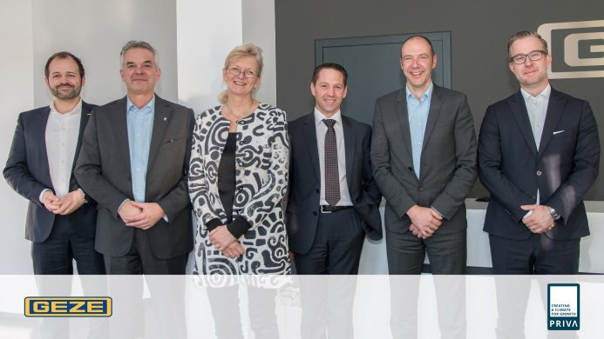
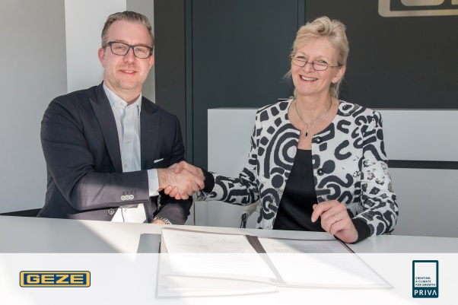

At the GEZE headquarter in Leonberg, Germany, representatives of Priva B.V. and GEZE GmbH signed the letter of intent.

Pictures: GEZE GmbH

GEZE and Priva plan to work together for future building automation

Priva B.V. and GEZE GmbH decided to sign a letter of intent to develop their cooperation in building automation systems and solutions.

Energy efficiency, safety and comfort are some of the most important requirements in the area of building automation across the globe. To realize them it is more important than ever to integrate all the elements in a building to ensure the mentioned topics. This presupposes collaboration and interdisciplinary cooperation between different product groups – so that the “internet of things” becomes accepted truth.

In the construction area the BACnet communication standard ensures open communication and interaction. Priva and GEZE have used this standard for years now. And here the cooperation starts.

Both companies are developing their automation products and solutions with the open standard. ‘”Therefore these solutions are highly compatible and this supports the creation of excellent added value for all our clients and end users – For example to adopt flexible solutions to specific customer needs” says Brigitte Vöster-Alber from GEZE. “This means we will be faster and more detailed in our answers to solve challenges in building automation”, agrees Meiny Prins from Priva. Priva and GEZE confirm the positive influence of this collaboration now and in future, for the coming benefits for their customers, especially.

To translate this LOI into action it is planned to create work streams around optimized building automation and visualization and to increase synergies around energy efficiency and comfort.

For clients and end users it is to offer the right blend of safety and convenience functions for intelligent visualisation, transparent monitoring, and efficient control of networked building automation. This ensures climate control, energy saving, optimal reuse of water and much more. Not only for utility buildings such as offices, retail, hotels and hospitals, but also for horticulture and indoor growing facilities.

Priva develops and produces technology for smart buildings, climate control and process management. The unique combination of software, hardware and services offers solutions for building automation, horticulture and indoor growing. The solutions Priva offers, result in a lower use of scarce natural resources like energy and water. They contribute to a more profitable business and sustainable growth for her customers. Priva is a family owned company with offices in thirteen countries. Together with an international network of certified Priva partners, Priva is active in over a hundred countries.

GEZE stands for innovation and for top quality products, processes and services. GEZE is one of the leaders in the global market and it is a reliable partner worldwide for door, window and safety technology products and systems. No matter what the requirements of a building are – GEZE implements optimum solutions and combines functionality and security with comfort and design. GEZE cockpit is one of these products and ensures unique networking of door and window technology with smart software and open interfaces to close the gap in building automation.

Press contact:  Julia Graf  Tel.: +49 (0)7152 203-505  Fax: +49 (0)7152 203-237  Email: j.graf@geze.com | GEZE GmbH  Reinhold-Vöster-Straße 21-29  D - 71229 Leonberg  www.geze.com
ABOUT GEZE
The GEZE brand stands for innovation and premium quality products, processes and services. GEZE is one of the leaders on the market and is a reliable partner worldwide for door, window and safety technology products and systems. No matter what the requirements of the building are – GEZE realises optimum solutions and combines functionality and security with comfort and design. GEZE door closers open up numerous technical and visual options. Every day millions of people go through doors equipped with the overhead door closers from the TS 5000 series and enjoy the barrier-free convenience of automatic door systems, e.g. the Slimdrive and Powerturn lines. The integrated all-glass design systems are pure aesthetics. GEZE also has a wide product range for window and ventilation technology. Complete "intelligent" smoke and heat exhaust solutions (RWA) and a comprehensive selection of door systems for RWA air supply solutions are also available for preventative fire protection. GEZE's safety technology includes escape and rescue route solutions, lock technology and access control systems. With system expertise, GEZE creates coordinated system solutions that combine individual functions and security requirements in one intelligent system. The latest innovations are the new building automation system GEZE Cockpit and interface modules for integrating GEZE products into networking solutions which turn buildings into Smart Buildings. GEZE product solutions have received numerous awards and can be found in renowned structures all over the world. The company is represented by 31 subsidiaries, 27 of which are abroad, a flexible and highly efficient distribution and service network and more than 2,800 employees worldwide and generated revenues of over 406 million Euros in the 2016/2017 business year. www.geze.com

