**TRADE FAIR PREVIEW REPORT FOR PUBLICATION**

Leonberg, 7th June 2017

**GEZE at SicherheitsExpo**

**5 - 6 July 2017 MOC Munich Hall 4, Stand E14**

**System integration made easy!**

**GEZE safety technology on doors and windows –automated, networked and intelligent**

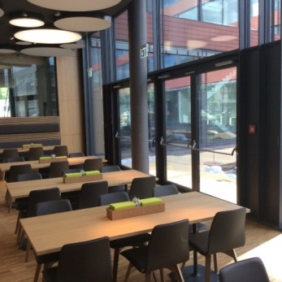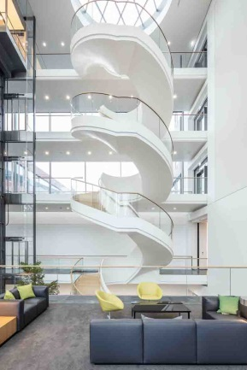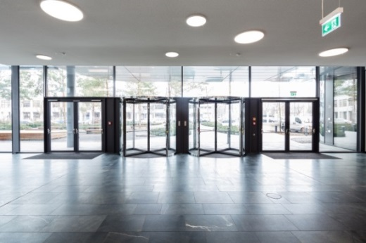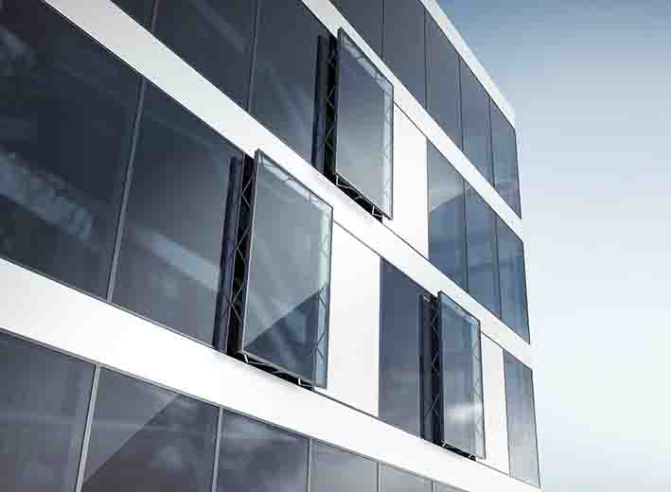

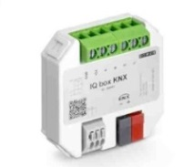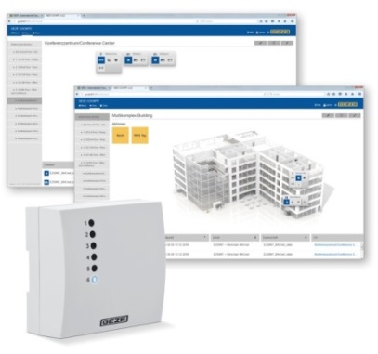

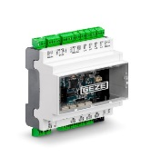

Photos: GEZE GmbH

**GEZE is making buildings safer and more convenient with its interdisciplinary networked safety solutions. From its large product range, GEZE will be presenting safety systems as intelligent participants in building management systems.**

The trade fair highlights will be the **new GEZE Cockpit building automation system** and **networking modules** for integrating GEZE safety products and systems into the building network. GEZE uses BACnet and KNX for this purpose – the most popular, open communication protocols in building automation in the world.

With GEZE Cockpit, automated GEZE products from the areas of door, window and safety technology can be controlled and monitored more securely, more efficiently and more conveniently. With the new system, the complete intelligence of the products can be incorporated into the building network for the first time: doors and windows can be controlled intelligently together with other participants of the system. Data exchange between GEZE Cockpit and the integrated doors and windows is carried out via the **IO 420 BACnet interface module**. The system can be used as an independent building automation system, or be integrated into a higher-ranking building control system.

GEZE will also demonstrate the networking of automated window systems that are integrated into a building automation system with the KNX standard. For controlled, natural ventilation, the GEZE chain and spindle drives of the IQ windowdrives series can be integrated as direct bus participants in KNX building systems via the award-winning **IQ box KNX interface module**. Automated windows can also be controlled and monitored intelligently from a central point.

**Perfect fit for safety – electric strikes from IST Systems**

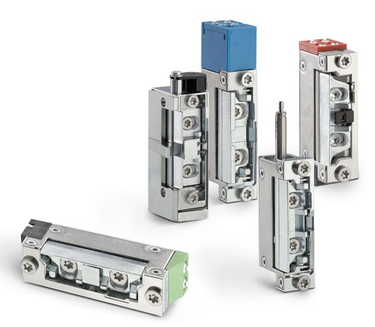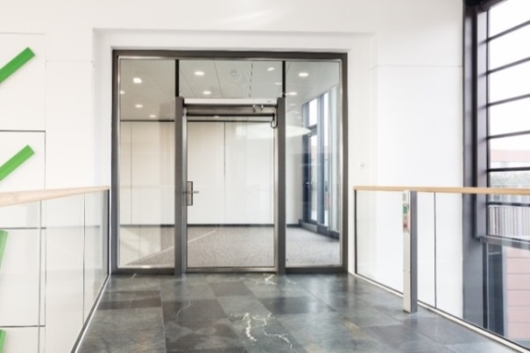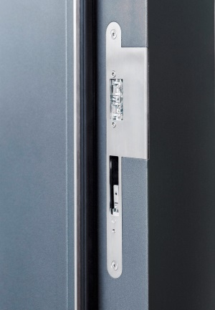

Photos: GEZE GmbH

GEZE will be presenting the complete range of electric strikes with variants for standard applications as well as fire protection and safety doors. IST systems electric strikes stand out thanks to small dimensions and compact configurations. They are compatible with electric strikes of all common manufacturers and can be easily replaced in existing doors. More than 300 versions help to realise solutions for different individual needs. It’s easy to choose the optimum IST System electric strike.