PRESS RELEASE FOR PUBLICATION

Leonberg, 03.08.2016

Successful merger between IST Systems and GEZE Group
Even more system solutions and services from a single source

IST Systems GmbH has for more than four years been part of GEZE GmbH, a specialist in door, window and safety technology. With the now successfully concluded process to merge the manufacturer of innovative electric strikes with the GEZE Group, customers will not only benefit from broader product combinations including easier ordering processes, but they can also enjoy new ancillary services – all from a single source.

IST Systems electric strikes are used in entrance doors for family homes, residential apartment blocks, larger buildings accessible to the public, and doors used as part of security interlocking door systems. Customers can now get these product solutions directly from GEZE GmbH, IST Systems' parent company. This simplifies ordering processes and offers prospective customers new possible combinations of, for example, IST electric strikes and GEZE automatic door systems. Finding the right IST product is fast and easy thanks to the new Product Finder at www.ist-systems.de. Furthermore, the comprehensive installation and maintenance services provided by GEZE are also available for IST Systems products. For example, for the new A4000 vector electric strikes: their particular strengths include almost silent door opening as well as secure release of the lock latch – even when under high preload and without the need for additional electronics. Customers and partners will benefit from even greater service and expertise from a single source because they can now order products and services related to electric strikes directly via GEZE. Nothing will change for the employees of IST Systems at the Albstadt site, however, as the merger was completed with no job losses.

"Serving our customers according to their individual needs with comprehensive solutions has always been our claim and the focus of what we do," says Brigitte Vöster-Alber, Chief Executive Officer of GEZE. "IST Systems products perfectly complement the GEZE product portfolio and complete our solutions in the field of automatic swing door systems, access control and smoke and fire protection doors. We are delighted that, with the merger of IST Systems, we can now offer our customers and partners even greater choice, efficiency and services."

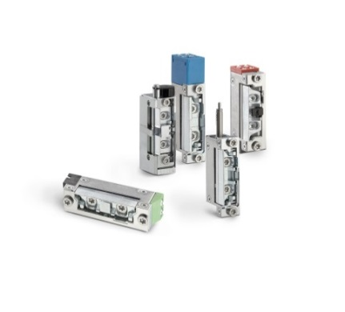

Photo: GEZE GmbH

With the typical small size expected from IST and the optional integration of the I.S.T.Kingfix latch guide, A4000 vector electric strikes give door manufacturers, installation engineers, architects, and planners new design options and greater planning security.

Press contact:  Julia Graf  Tel.: +49 (0) 7152 203-505  j.graf@geze.com  Fax: +49 (0) 7152 203-237 | GEZE GmbH  Reinhold-Vöster-Str. 21-29  D-71229 Leonberg  www.geze.com

About GEZE
The GEZE name stands for innovation and the highest quality of products, processes and service. As one of the global market leaders for door, window and safety technology systems, GEZE GmbH has had a decisive influence on building management systems with its pioneering developments. GEZE door closers open up a numerous technical and visual possibilities. Every day millions of people walk through doors fitted with GEZE's TS 5000 series overhead door closers and enjoy the natural convenience of automatic door systems, such as the Slimdrive product line. Barrier-free door and window systems offer maximum convenience, not only for people with restricted mobility. The integrated all-glass systems provide architectural design freedom. GEZE fitting solutions, such as the attractively designed sliding systems, are award-winning. What's more, GEZE provides a wide range of products in the field of window and ventilation technology as well as smoke and heat extraction systems (RWA). The safety technology field encompasses escape and rescue route solutions, locking technology, and access control systems. GEZE's building management system provides an overview of all the building systems. As a provider of systems, GEZE creates not only stand-alone but also coordinated system solutions which combine functional and safety requirements in a single intelligent system. Product solutions from GEZE can be found in renowned structures throughout the world. The company has a worldwide presence with 31 subsidiaries, 27 of which are outside Germany, a flexible and highly efficient sales and service network, and almost 2,800 employees, and in the 2014/2015 fiscal year it achieved a turnover of over 366 million euros.
www.geze.com

