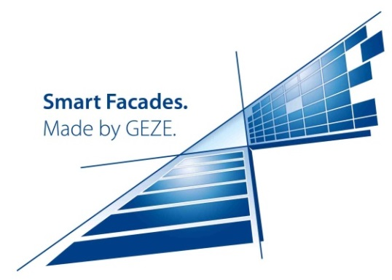**Press releaseS for publication**

**GEZE at BAU Trade Fair 2017**

**16 - 21 January 2017, Messe München exhibition centre,**

**Hall B1, Stand 538-539**

Leonberg, 16/01/2017

**Professional solutions with KNX**

**Intelligent building control – energy-efficient facades: smart and safe ventilation**

**OVERview: This file contains six press releases:**

**The new GEZE IQ box KNX interface module – dialogue between windows and components**

*System solution:*

**The climate-active facade: IQ windowdrives for 'intelligent' windows in KNX building systems**

*System solution:*

**Automatic night-time back cooling: great comfort and safety for large windows**

**The F 1200 Electric turn-and-tilt hardware**

*System solution:*

**Security in the building bus unit: natural ventilation and indoor climate control**

*Reference report:*

**For a whole office complex: comfort, safety and energy efficiency**

**Discreet and reliable 'bodyguards':**

**GEZE window protection for automated windows in the KNX building bus**

**Press release for publication**

**GEZE at BAU Trade Fair 2017**

**16 - 21 January 2017, Messe München exhibition centre,**

**Hall B1, Stand 538-539**

Leonberg, 16/01/2017

**Professional solutions**

**Energy efficient facades: smart and safe ventilation in the KNX environment**

**The new GEZE IQ box KNX interface module – dialogue between windows and components**

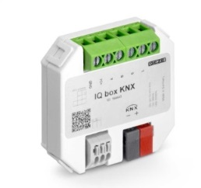

**Whether in public buildings, office buildings or schools – energy-efficient ventilation, a healthy indoor climate and monitoring the window statuses are central demands for large projects. Networked solutions from GEZE fulfil them: a 'climate active' facade is created as the result of the intelligent interplay between window drives and sensors which record external environmental influences and the indoor climate. Automatic windows are an ideal solution for automatic natural night-time back cooling. Automatic windows can be monitored and operated intelligently via IQ box KNX interface module, integrated into the KNX communication standard. The module has won the Silver PROTECTOR Award.**

Photos: GEZE GmbH

More intelligent ventilation: windows with IQ windowdrives can be integrated into the KNX building bus via the IQ box KNX interface module.

The intelligent drives of the IQ windowdrives series can be integrated into KNX building systems as direct bus participants for controlled natural ventilation. Window statuses (e.g. open/closed) are then displayed on a central visualisation, and controlled and checked from there. Thus automated, the windows allow direct communication with other components in the KNX building system, such as KNX push buttons and KNX sensors. In this way, all windows in a building can be closed centrally at the push of a button. If a KNX weather station or a KNX air quality sensor reports rainfall, wind, a concentration of CO2 which is too high, or a temperature difference, the window drives will receive the signal to close or open via the IQ box KNX. Via precise activation of the window drives, the module enables energy saving potential and offers additional safety: in contrast to simple switch contacts, it uses the 'intelligence' of the window drives and after performing a 'command', reports the status of a window to the KNX building system or building management system. Additional window information is also provided by the IQ box KNX, e.g. the precise opening width, any faults, or the number of opening and closing cycles.



**Press release for publication**

**GEZE at BAU Trade Fair 2017**

**16 - 21 January 2017, Messe München exhibition centre,**

**Hall B1, Stand 538-539**

Leonberg, 16/01/2017

**Professional solutions**

**Energy efficient facades: smart and safe ventilation in the KNX environment**

**The climate-active facade: IQ windowdrives for 'intelligent' windows in KNX building systems**

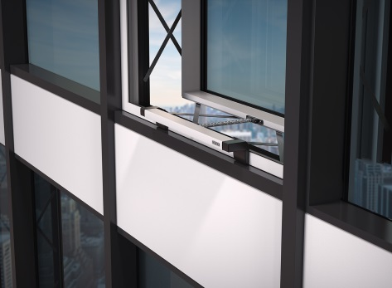

**The window drives from the IQ windowdrives series can be connected to the KNX building bus unit via the new IQ box KNX interface module, for a perfectly energy-efficient indoor climate through controlled natural ventilation. Additional components – such as heating or air-conditioning – can also be integrated via KNX actuators. KNX air quality sensors and KNX weather stations supply the information on room air quality and external environmental conditions, thereby ensuring that there is no 'thick air'.**

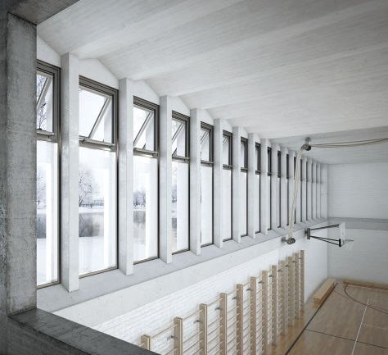The Slimchain and Powerchain chain drives can be flexibly used. The Slimchain is the slim all-rounder. For instance, it can be used very easily for automating parallel-opening vent windows, supporting an efficient exchange of air with a facade view which is always consistent. The Powerchain is the power package for large and heavy facade windows, roof windows and light domes. The drives differentiate between alarm (RWA) and ventilation mode, i.e. a fast and maximum or a slow, limited and virtually noiseless opening. The adjustable drive stroke and the opening speed which can be individually adapted enable use on RWA and ventilation windows of various closing forces and with different opening requirements. If an 'RWA event' occurs, the drives can attain very large opening widths in under 60 seconds.

Photos: GEZE GmbH

The 'intelligent' IQ windowdrives chain drives

from above: the slim Slimchain and the 'strong' Powerchain – can be integrated via the IQ box KNX interface module into a KNX building system

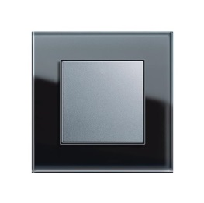The integrated, intelligent control allows drives to be combined easily. The control unit ensures the sequential and safe opening and closing of the windows, as well as the synchronisation of up to three drives.

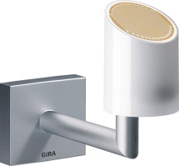

The Gira KNX air quality sensor for monitoring air quality, temperature and humidity in individual rooms.

Gira KNX weather station for measuring and evaluating wind speeds, rainfall, darkness and temperature.

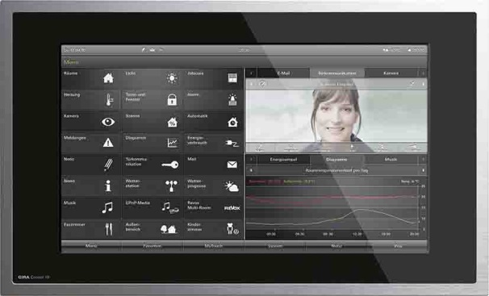

The KNX GIRA Control room control unit – the central operating device makes it easy to control the entire building system

Image rights: Gira, Giersiepen GmbH & Co. KG, Stand 12/2016,

Subject to changes and possible errors

**Press release for publication**

**GEZE at BAU Trade Fair 2017**

**16 - 21 January 2017, Messe München exhibition centre,**

**Hall B1, Stand 538-539**

Leonberg, 16/01/2017

**Professional solutions**

**Energy efficient facades: smart and safe ventilation in the KNX environment**

**Automatic night-time back cooling: great comfort and safety for large windows**

**The F 1200 Electric turn-and-tilt hardware**

**The motorised 'intelligent' F 1200 Electric turn-and-tilt hardware is a perfect new solution for controlled natural ventilation with great user convenience for particularly large and heavy bottom-hung windows. It enables automatic, natural night-time cooling via the building management system – a major advantage in the summer months, which also contributes to environmentally friendly building air conditioning. Sensors help with the necessary security, so that there is no danger of getting jammed during the automated closing process.**



Photos: GEZE GmbH

The F 1200 Electric turn-and-tilt hardware –

ideal for large and heavy bottom-hung windows

It can be integrated into a KNX building bus unit via the IQ box KNX interface module.

F 1200 Electric makes natural controlled ventilation so much easier in office buildings, schools, sports venues or hospitals with windows which can only be brought into a tilted position and closed again manually with a large amount of physical strain. Window leaves weighing up to 200 kg can be opened 180 mm wide in a tilted position. The opening width can be modified from gap ventilation to a maximum tilted position with variable adjustment. The window leaf can also be opened manually; the window fitting is unlocked and brought into the rotary position via the drive. The rotary opening ability can be limited to authorised persons with a key switch. An additional, optional operating error protection makes the system particularly robust and safe. The hardware can be adjusted from a comfortable height, is very robust and therefore burglar-resistant, and also fulfils high demands for thickness and thermal insulation.

**Security in the building bus unit: natural ventilation and indoor climate control**

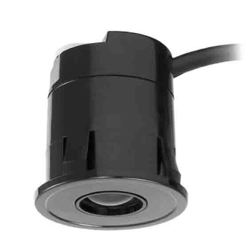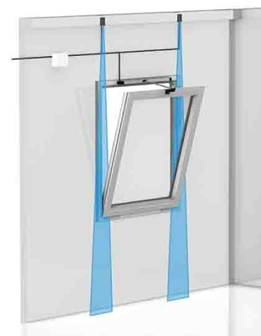

TOF/Spot Sensor time of flight measurement (AIR):

precise light beam – protecting through adjustable spots

Photos: GEZE GmbH

GEZE presents its system expertise with the combination of a window element, the F 1200 Electric turn-and-tilt hardware, the GEZE indoor climate control for various ventilation scenarios, and the new discreet, self-monitored compact sensor TOF/Spot time of flight measurement (AIR). The sensor secures precise fields in the window area. Integrated into the building system via the IQ box KNX, the complete window system can be controlled monitored and visualised at a central point. The Elsner WS 1000 Style 4-PF building control serves as the visualisation and central operating unit for all window functions.

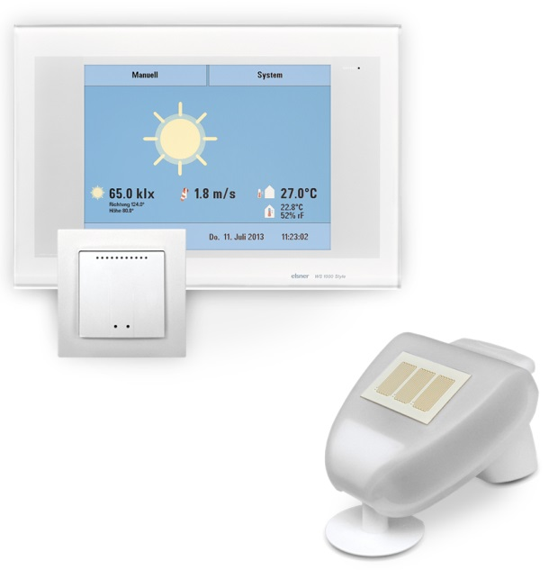

The WS1000 Style building control for a wide variety of ventilation scenarios, with control panel, WGTH-UP radio indoor sensor (central unit), and weather station

Image rights: Elsner Elektronik GmbH, edition 12/2016, subject to changes and possible errors

**Press release for publication**

**GEZE at BAU Trade Fair 2017**

**16 - 21 January 2017, Messe München exhibition centre,**

**Hall B1, Stand 538-539**

Leonberg, 16/01/2017

**Professional solutions**

**Energy efficient facades: smart and safe ventilation in the KNX environment**

***Reference report:***

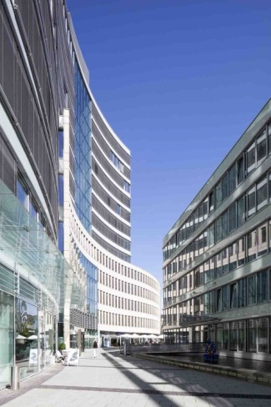**For a whole office complex: comfort, safety and energy efficiency**

**GEZE is at the moment realising a complex project for the building network and integration of windows into the building management system of a Frankfurt office complex. The result will be more convenient, cost-effective and energy-efficient building monitoring. This new solution is part of the package of measures which run for the international building standard LEED / German Sustainable Building Council / in Gold.**

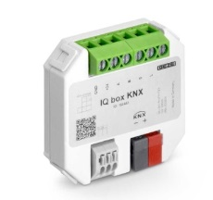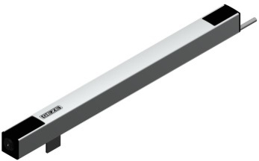For this, GEZE has developed a project-specific automation solution for windows. Initially, 400 bottom-hung windows will be automated with smart, GEZE F 1200 Electric drives, especially developed for this project. The windows are being integrated into the existing KNX building system via GEZE's new IQ box KNX interface modules. Thanks to the object expertise of the GEZE 'Customer Solutions' department, most of the existing window fittings can be used again. Therefore, the investment funds for the building owners can be kept low, compared to other modernisation solutions.

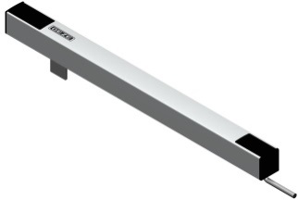The demands for modernised window systems are firstly natural automated night-time back cooling and secondly, daily room ventilation 'at the touch of a button'. Heating and climate-controlled ceilings are controlled depending on the window position (open/closed) in an energy efficient way. Since heating control and window drives are interconnected, windows are closed when the heating or air-conditioning is activated, but also if rain or wind starts. Natural ventilation occurs automatically in the same way. The central control system makes it possible to control entire window frontages or defined groups of windows for night-time back cooling. If needs change, new ventilation scenarios can be defined on a KNX visualisation panel.

Photos: GEZE GmbH

**Press release for publication**

**GEZE at BAU Trade Fair 2017**

**16 - 21 January 2017, Messe München exhibition centre,**

**Hall B1, Stand 538-539**

Leonberg, 16/01/2017

**Professional solutions**

**Energy efficient facades: smart and safe ventilation**

**Discreet and reliable 'bodyguards'**

**GEZE window protection for automated windows in the KNX building bus**

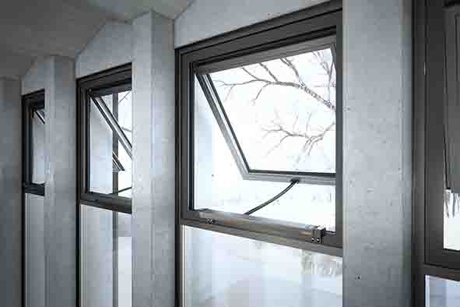

**The new window protection from GEZE** **provides increased security and comfort. It can be combined perfectly with the window drive portfolio. The sensors are used wherever they are needed according to a safety analysis, and offer the high levels of safety standards in accordance with Performance Level C.**

Photos: GEZE GmbH

The GEZE window protection can be used for the large-scale protection of complete window facade sections, and for individual or linked windows of virtually any window type. The protection can also be used on windows which are controlled in different ways: through building management systems, with offset activation devices or with corresponding sensors (e.g. of the GEZE indoor climate control). If windows are integrated into a KNX building system and are opened or closed automatically via the IQ box KNX interface module, the window protection deactivates the drive in case of danger. The different sensor solutions can be integrated unobtrusively into facades, ceilings or frame elements. Commissioning is simple and convenient – without software, configuration or prefabrication. Status displays for the windows and signals can be issued at a central point, e.g. a control panel or LED display in a technology room.

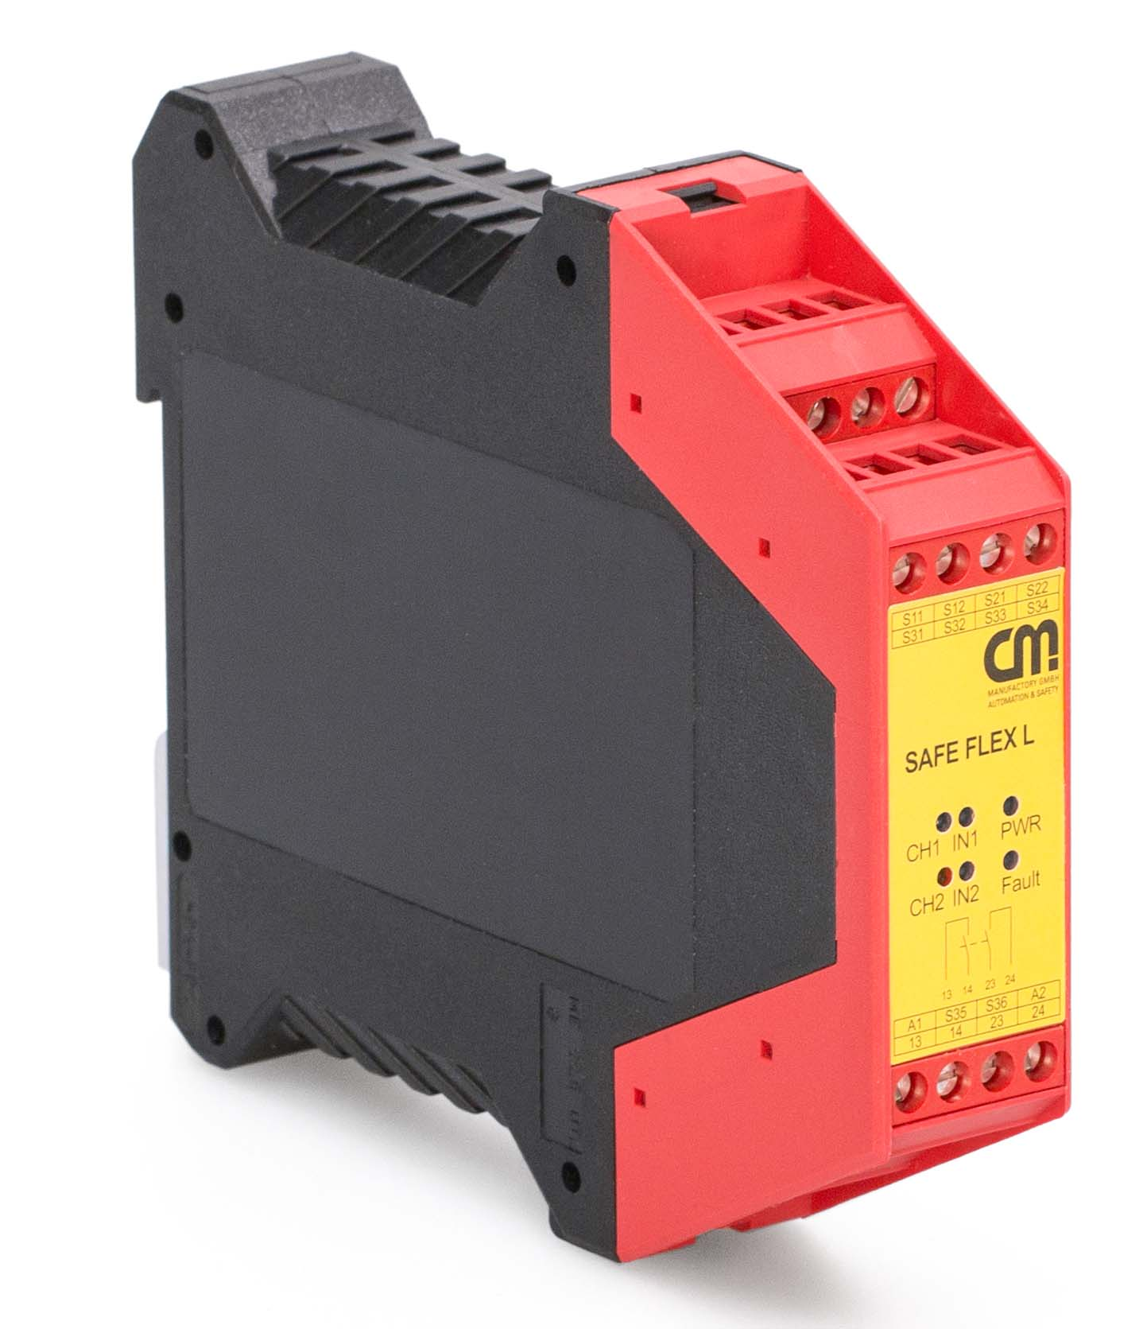

The basis of window protection:

the GEZE safety switching device

window protection system

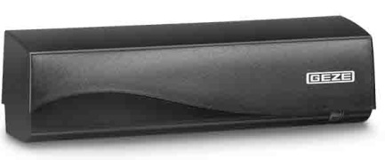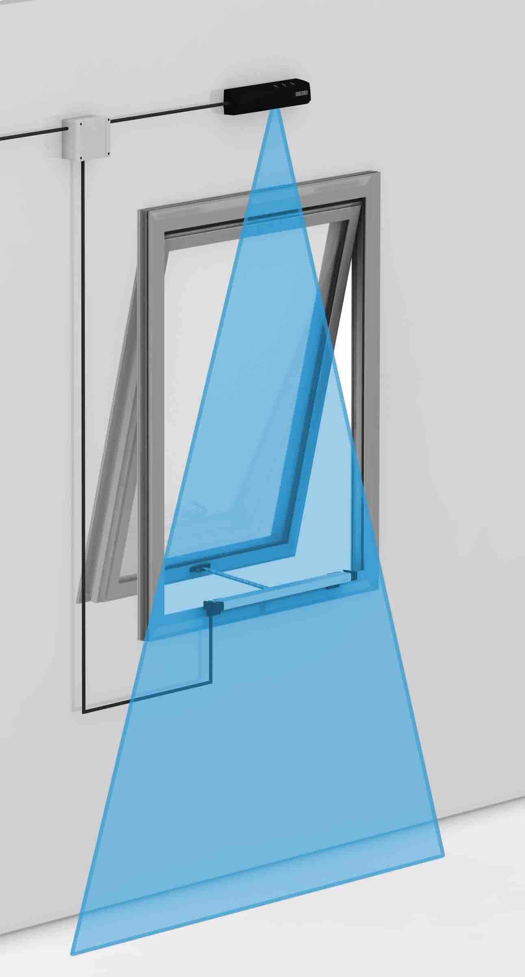

GEZE GC 339 light curtain:

invisible and non-contact protective device



TOF/Spot Sensor time of flight measurement (AIR):

precise light beam – protection through adjustable spots

Photos: GEZE GmbH



LZR-I100 Laser Scanner:

large-scale protection via a light curtain

TOF/Spot Sensor time of flight measurement (AIR):