Reference report for publication

Leonberg, 8th November 2017

Dubai Opera: GEZE automatic door solutions in "maritime" architecture

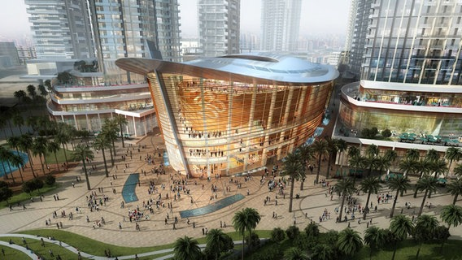
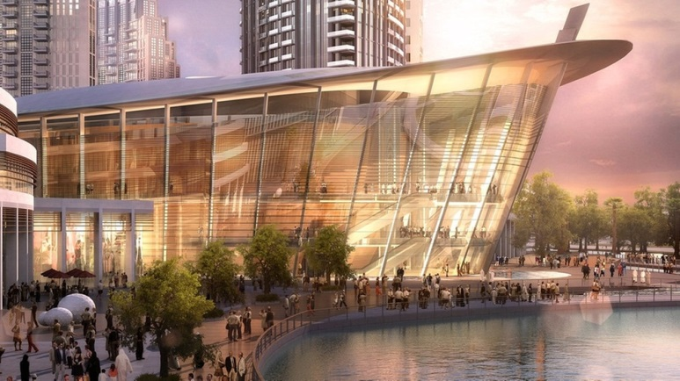

Image source: Dubai Opera LLC

Image source: Dubai Opera LLC

Dubai Opera is a truly unique venue and the city’s first purpose-built multi-format performing arts theatre situated in the heart of Downtown Dubai. Offering the ultimate flexibility of a proscenium arch theatre, an acoustic concert hall and a 2000 square metres flat floor event space, the configuration allows for approximately 2000 seats for a concert and up to 1000 for a gala dinner. Outside of the main auditorium, the venue has a smaller performance space and rehearsal room and a stunning rooftop restaurant and sky garden with views of Burj Khalifa and The Dubai Fountain.
With an iconic dhow shaped design rooted in Emirati heritage, Dubai Opera opened on 31st August 2016 with a spectacular performance by legendary tenor Plácido Domingo. The vision is to entertain and enrich Dubai’s residents and visitors, and be the definitive destination for quality entertainment productions and performances. Dubai Opera's stage hosts an incredible array of world-class talent. With opera, ballet and classical music concerts and productions at the core, Dubai Opera also stages musical theatre, fashion shows, jazz, comedy, family shows and a full range of live entertainment to appeal to the incredibly cosmopolitan population who live, work in and visit Dubai.

Traditional styles within the futuristic design of the buildings:
creative freedom with Powerturn swing door systems
The building was designed by Janus Rostock, the leading architect for Middle Eastern projects in the global engineering and architecture firm, Atkins. The automatic swing door systems with GEZE Powerturn drives blend harmoniously into the post-modern architecture. The drives provide optimum flexibility for designing door solutions in a whole variety of different building settings, combining functional versatility with a discreet appearance. That's why the "Powerturn doors" are ideal solutions for the glass facades whose sloping design – just like the curve of the roof – was also modelled on the dhows.

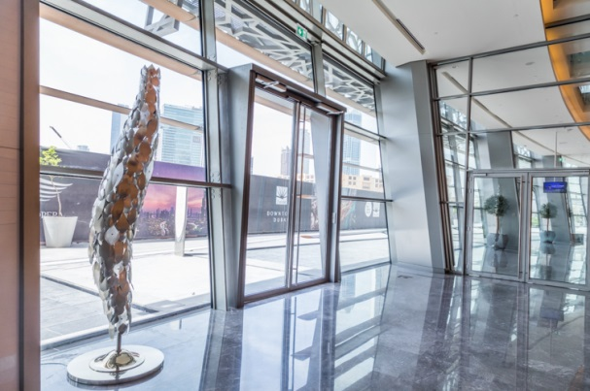
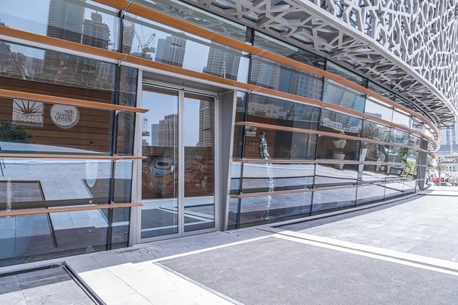

One of the many entrance facades featuring Powerturn swing door systems
Photos: GEZE GmbH

The Powerturn swing door drives are true power packages and move the large, heavy glass leaves of thirteen double-leaf swing door systems in the transparent façade quietly, easily and safely, automatically giving visitors barrier-free access to the venue. Their unique Smart swing function enables Powerturn doors to be easily opened by hand from the inside. As is typical for GEZE, the drive has a very discreet design and is just seven centimetres high. The wide-opening escape doors enable everyone to get out of the building really quickly if there is any danger such as a fire – even if there is a power failure. If the doors are not operated in automatic mode they are kept shut by the FTV 320 escape door lock. This is so small that it takes up minimal space in the very slim door profiles. When the opening button inside the building is activated or if a signal is received from the fire detector central unit, the escape door lock is released and the Powerturn drives open the door leaves. The special door locking system with three latches is very secure. Due to its secure unlocking mechanism even under heavy side loads, the FTV 320 makes reliable opening possible even if fleeing people press against the door in a panic situation.

Building and swing door systems: twin commendation
With two Plus X Awards to their credit, the Powerturn drives are the flagships of GEZE's range of swing door drives. They can be counted as one of the factors which at the end of 2016 contributed to Dubai Opera winning the "Project of the Year" and "Best Public Building" awards as part of the "Identity Design Awards" sponsored by the architecture and design magazine identity.

Held-open: maximum building safety

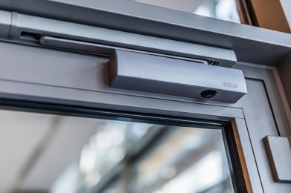
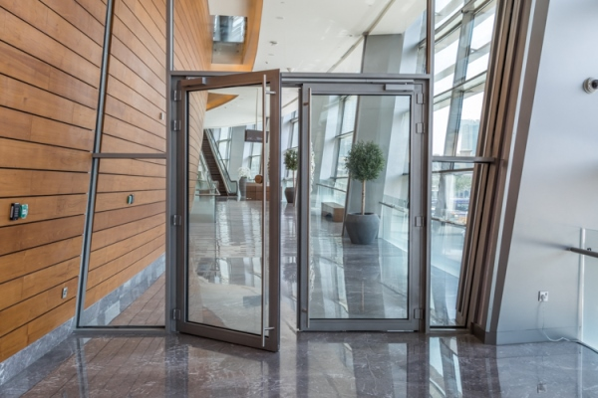
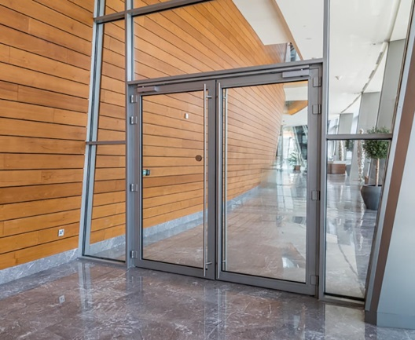

Photos: GEZE GmbH

Hold-open systems with the TS 5000 E-ISM door closer system and TS 5000 door closers

Barrier-free convenience, fire protection and discreet design are the requirements for the numerous manual double-leaf swing doors which lead from the staircase hallways to the three upper storeys. Hold-open systems were chosen so that the doors can be left open but shut automatically in the event of a fire. They electrically hold the doors open until they are closed either manually or by the triggering of a fire detector. A TS 5000 E-ISM door closer system enables the doors to be electromechanically held open with variable adjustment on either side. The hold-open bracket for the door leaves can be individually set within in a range of 80 to 130 degrees, allowing the doors to be adapted to differing structural circumstances. The continuous, discreet E-ISM guide rail is only visible when the door is open. It includes the electro-magnetic (E) hold-open device for both door leaves and an integrated closing sequence control. If both door leaves are open and engaged, once the hold-open device has been released in the event of a fire it ensures that they are closed securely and in the right order. With variable settings of up to a strong EN 6 closing force, the doors close reliably and securely. The TS 5000 E-ISM system is also permitted on fire and smoke protection doors because the GEZE products in the Dubai Opera naturally comply with all the current European norms and safety standards.

