REFERENCE REPORT FOR PUBLICATION
Leonberg, 26th July 2017
Barrier-free planning and building with GEZE
Modern, automatic door and window solutions in the new Leonberg town hall

All photos: GEZE GmbH
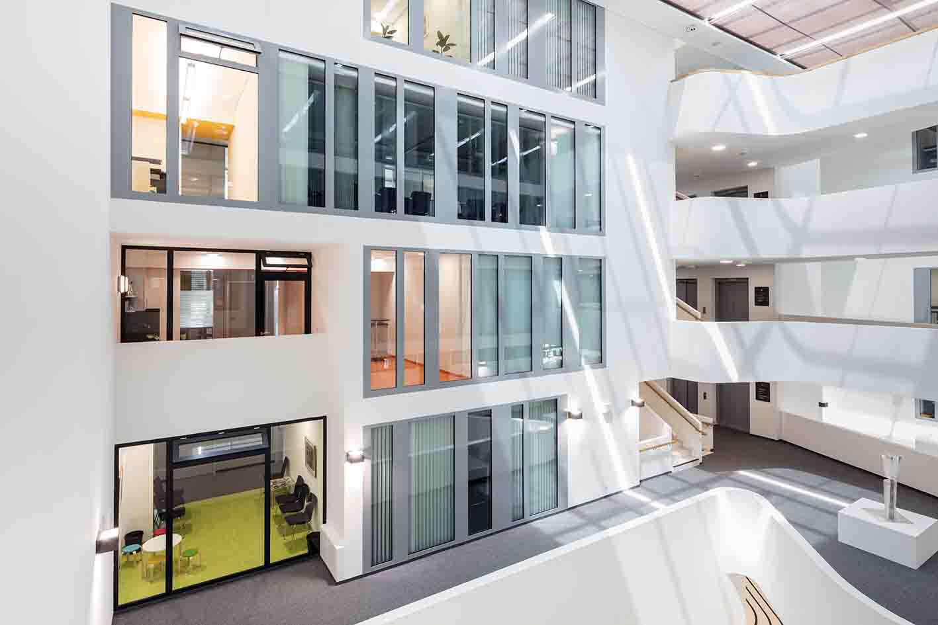
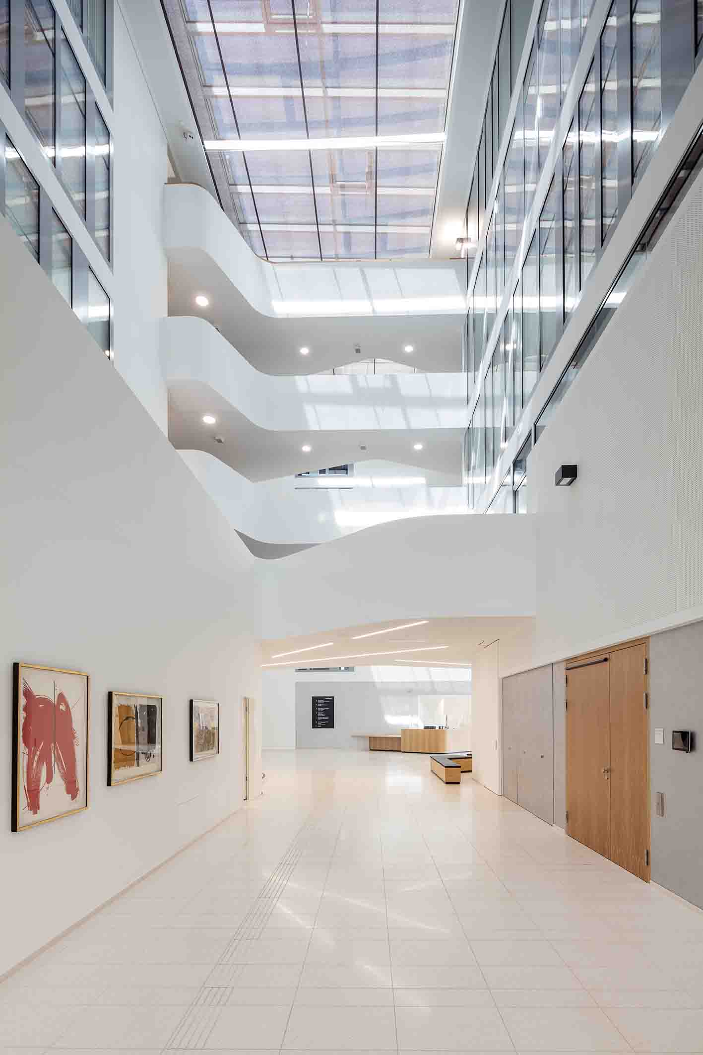

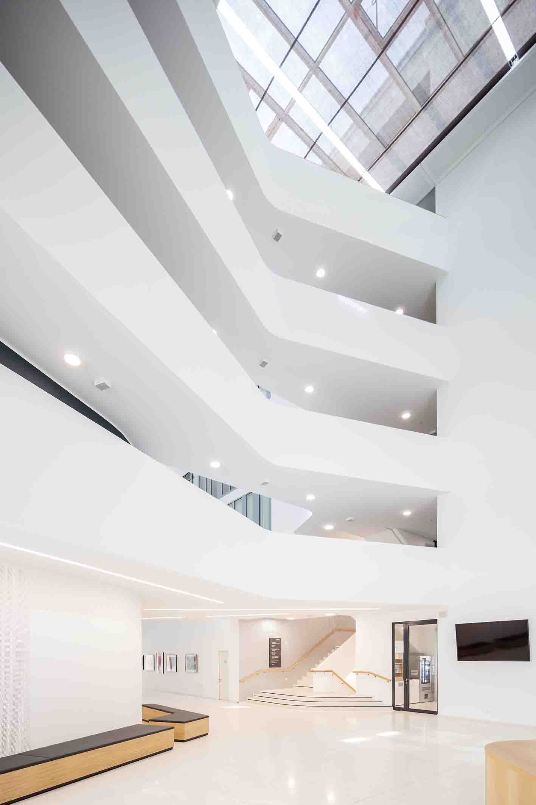
Between the historic old town of Leonberg and the city’s "new town centre" a new 9,900 square metre building, which is open on three sides, has been built for the town's inhabitants and the more than 200 employees of the urban administration. In a park-like landscape with a promenade garden, the new town hall is an urban showpiece for an attractive town with vibrant traditions and a great quality of life.

In order to provide the best possible service for citizens in a light, open atmosphere, the administration and functional areas have been brought together in a modern town hall with a clean, simple design. Internal routes are now shorter and simpler, and access is barrier-free. The building offers increased security and a sustainable energy strategy. The centrepiece of the partially circular six-storey building complex is the atrium with a large glass roof. The ground floor accommodates the central foyer with the reception area and info point, the council chamber that can be divided into smaller units, and rooms for the political parties represented in the town council as well as a cafeteria. From here one reaches the gallery-style upper storeys with the points of contact for citizens as well as the individual offices.

Indispensable features of atrium of the new Leonberg town hall: smoke and heat extraction systems

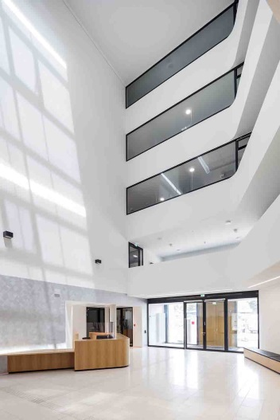
Comprehensive GEZE service: "barrier-free" design
In modern public buildings, access for all is standard as a matter of course. A building must be easy to access and able to be used without other people's help. The GEZE project experts supported the construction project right from the planning phase, contributing their lengthy and comprehensive experience of realising barrier-free buildings. A special service provided by them was the concept for executing all the measures for barrier-free use of the building, which was an important planning support for the city`s representatives, the architects from Schaller architectural practice, and the general contractor, Wolff & Müller.

The design was drawn up according to the needs of the building's various user groups in accordance with all the legal rules, and also in design with DIN 18040-1 as the planning basis for "Barrier freedom in publicly accessible buildings". This means that publicly accessible areas must be easy for all visitors to find, access and use on their own, including for instance people with impaired or no visual or hearing abilities. This involved taking economic considerations into account, and also of course combining access for all with the fire protection and emergency exit safety requirements.

A showcase for "Powerturn" swing door systems: a wide range of functions and creative freedom
It's worthwhile visiting the town hall even if you haven't got an issue to be dealt there. The outdoor facilities are a valuable "green" space which invites you to linger with its terraces to sit on, its benches, and a fountain which gushes from the ground. The building's outer and inner rooms merge almost unnoticeably into each other. Tactile guide strips show the way across the classy, stylish forecourt to the main entrance and through to the reception desk in the foyer. A tour of the impressive town hall shows the variety of GEZE's door and window solutions which ensure access for all while providing fire protection and escape routes.

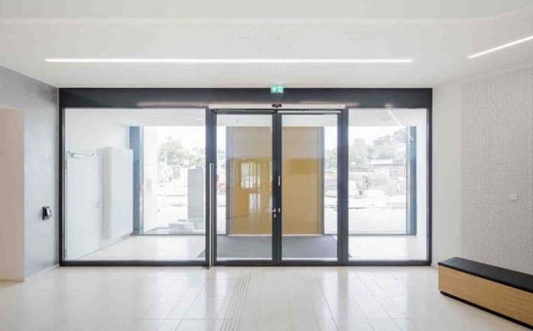
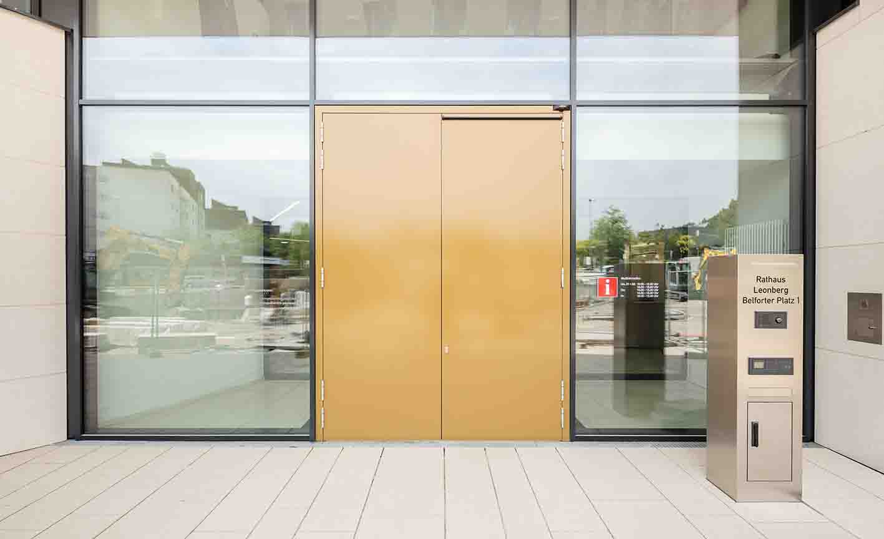

Barrier-free: the main entrance featuring automatic swing door systems with "robust" Powerturn drives

Throughout the whole building, automatic swing door systems with the innovative Powerturn drives are used. To provide barrier-free access in the vestibule of the main entrance each active leaf of the two tall, heavy double-leaf doors has been automated with the powerful but discreet drives. Powerturn doors have a very special advantage: their unique Smart swing function enables them to be opened manually quite easily by anyone. When opened widely, the emergency exit doors also act as a ventilation opening for fresh air in the event of a fire.

A further entrance façade has been created for the cafeteria by fitting the outer double-leaf vestibule door with the Powerturn IS/TS version. The active leaf has been automated, and the passive leaf is held closed with a TS 5000 door closer. The drive nevertheless extends across both door leaves, which is an impressive feature of this solution. The fire protection door used on the inside of the inner, single-leaf vestibule door is equipped with a Powerturn F/R with integrated smoke switch. This is an ideal solution for this area due to the shortage of space – the integrated smoke switch is directly underneath the drive cover. From the outside, barrier-free access to the vestibule is provided by a radar movement detector. At certain times it is necessary to "ring the bell'. Then the door is opened automatically via the programme switch at the reception desk.

Powerturn F/R-IS/TS swing door drive systems provide safety and comfort on the two double-leaf fire section and emergency exits in the third entrance façade to the council chamber. Here too, each of the active leaves has been automated to provide barrier-free access. The integrated closing sequence control closes the door leaves in the right sequence after the door is used (above all by escaping people) so that the protective function of the fire door is restored.

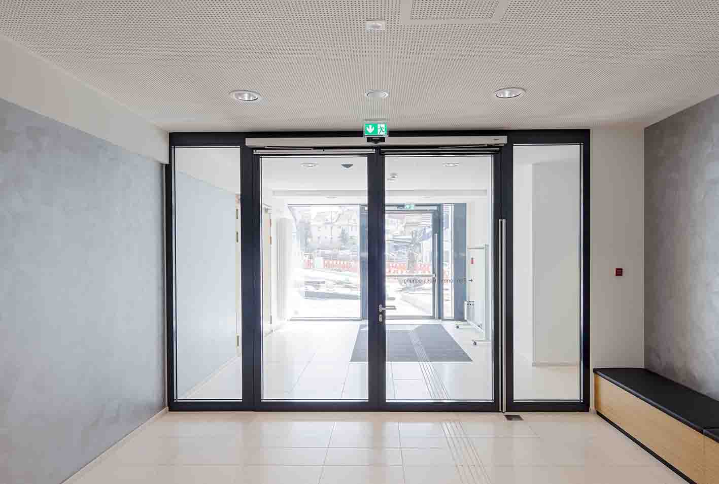
Entrance façade to the council chamber with Powerturn F/R-IS/TS swing door drive systems

In the council chamber: fire protection and a clear escape route

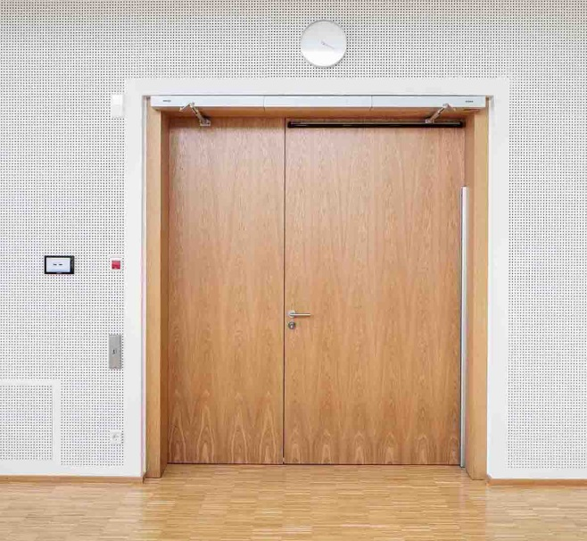
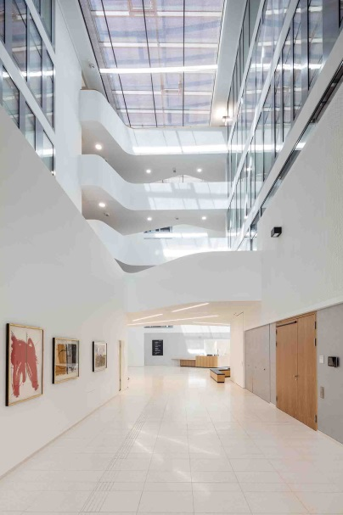

Double-leaf fire protection doors as council chamber doors

In the foyer two double-leaf fire protection doors with Powerturn F/R-IS/TS lead into the council chamber that can be subdivided. They are activated by elbow switches. In the event of a fire, the doors close automatically and stop the fire from spreading. In the foyer all the automatic doors can be controlled and monitored via a display programme switch at the reception desk.

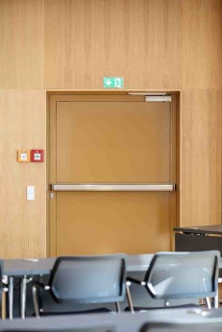
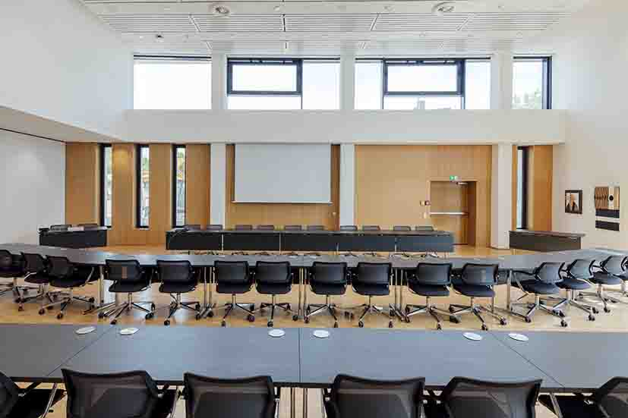
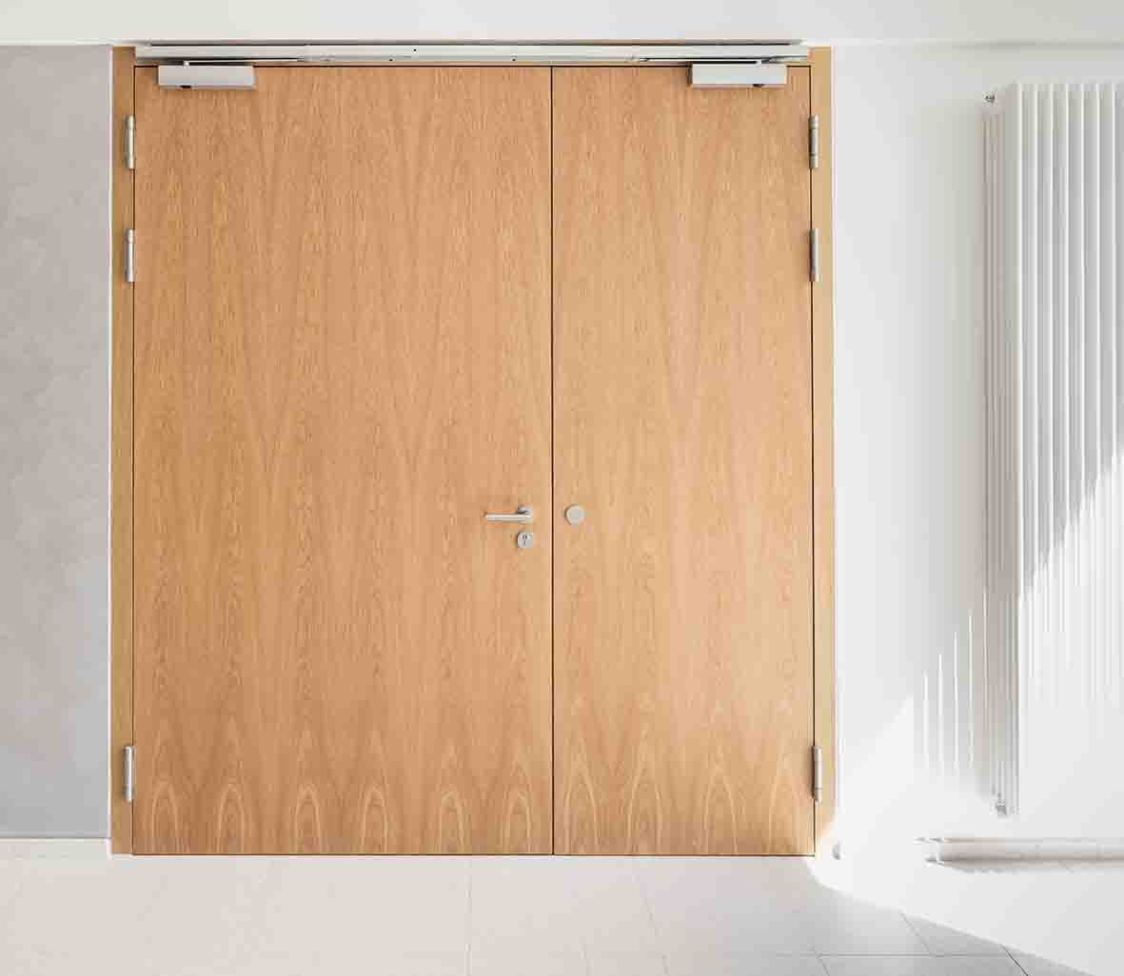

Left: double-leaf hold-open system as the third access to the council chamber
Right: escape door to the outside with door closer and push bar

The third entrance to the council chamber is a visually discreet, compact double-leaf hold-open system with TS 5000 R-ISM door closers. The door leaves can be kept open and be reliably shut in the event of a fire. Thanks to the free swing function the door can be opened with the use of minimal physical force. In day-to-day use these doors behave as though there is no door closer fitted. A further major advantage is the comfort hold-open function which enables the doors to be simply locked in position at the end of the free swing area without closing in an uncontrolled manner or jamming in a partially closed position. This does not impede the automatic closing of the doors in the event of a fire. The same door solutions were chosen as single-leaf entrances to the rooms for the political parties. In addition, two escape doors fitted with TS 5000 door closers lead to the outside.
Intelligent smoke and heat extraction – barrier-free ventilation

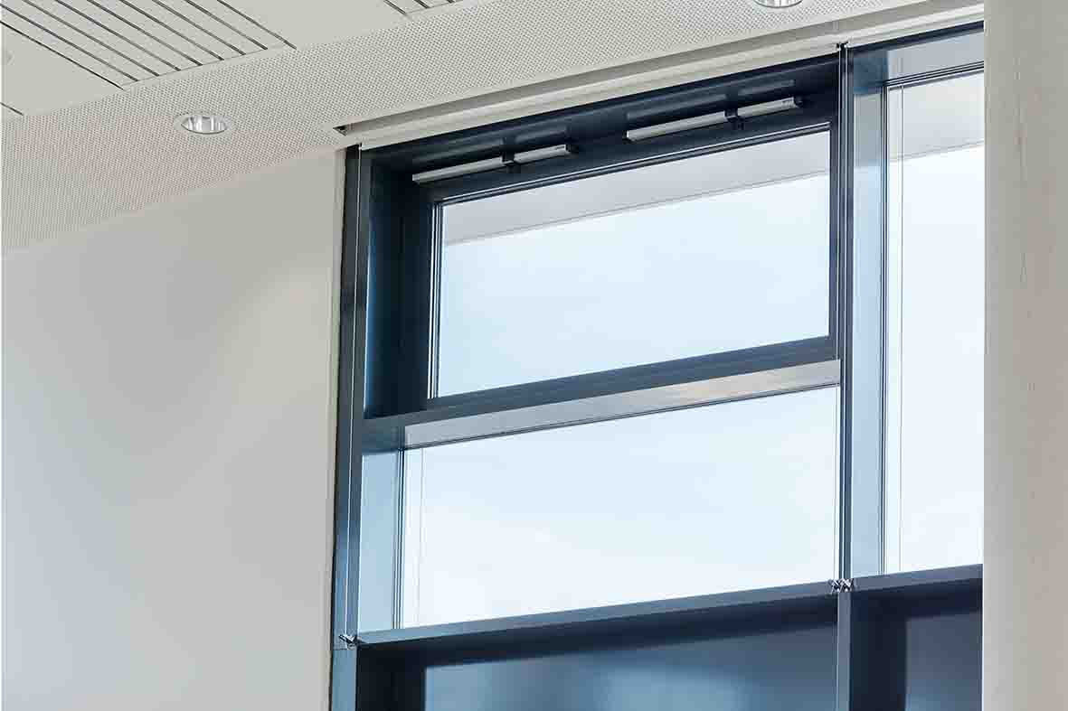
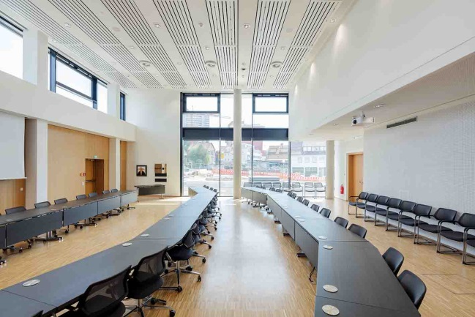

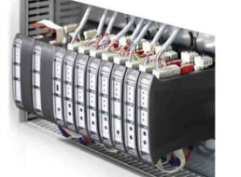

Right-hand photo: the modular MBZ 300 RWA central control unit
In order to remove smoke from the council chamber as soon as it arises so that everyone gets out safely through the escape doors, a smoke and heat extraction system (RWA) has been installed. On both sides of the façade the windows directly under the ceiling have been automated with discreet Slimchain drives in Syncro version. If smoke and heat extraction is necessary, the sun shields immediately retract and the window drives open in high-speed mode. The flexibly configurable MBZ 300 RWA bus control unit takes over the electricity and emergency electricity supply as well as the coordination and monitoring of the window systems and components that can be individually activated, e.g. sensors, push buttons or smoke detectors. Triggered by the manual RWA button or the fire detector system, the MBZ 300 opens the windows on the leeward side of the building to provide reliable smoke removal. Slimchain drives are "intelligent": they can also provide alarm messages and all the window information (open/closed, exact opening width) to the on-site KNX building system. The smoke and heat extraction system consequently has a double function: as well as being a safety-oriented application in the event of a fire, it provides comfortable day-to-day ventilation. An internal ventilation window feeds fresh air from the foyer into the council chamber to ensure a "good atmosphere".
Held-open: barrier-free fire sections
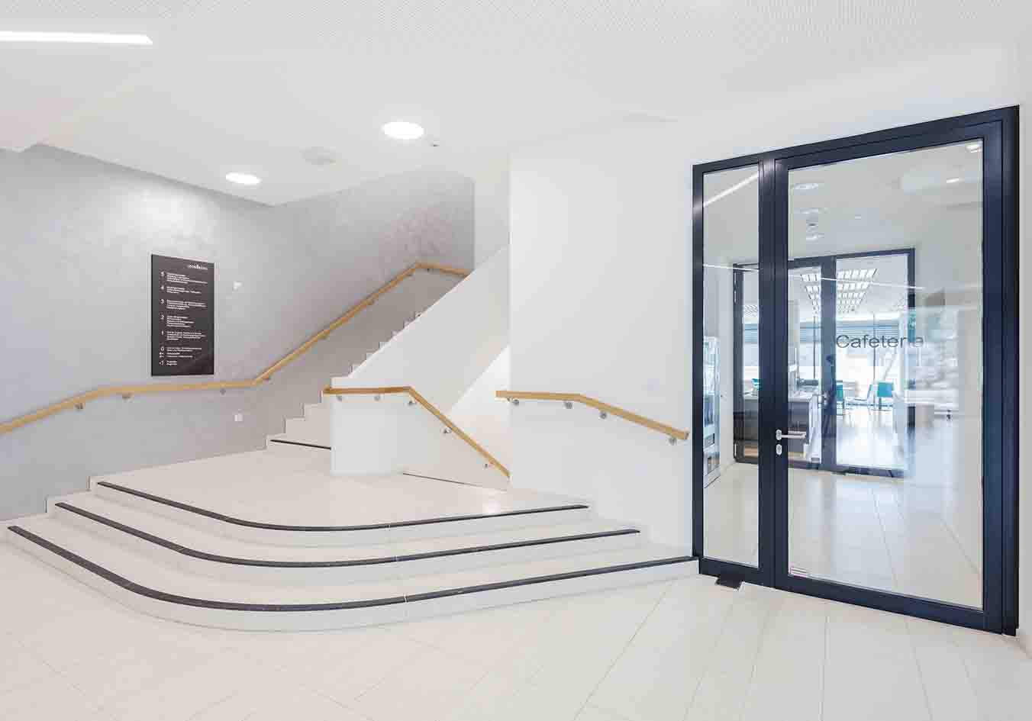
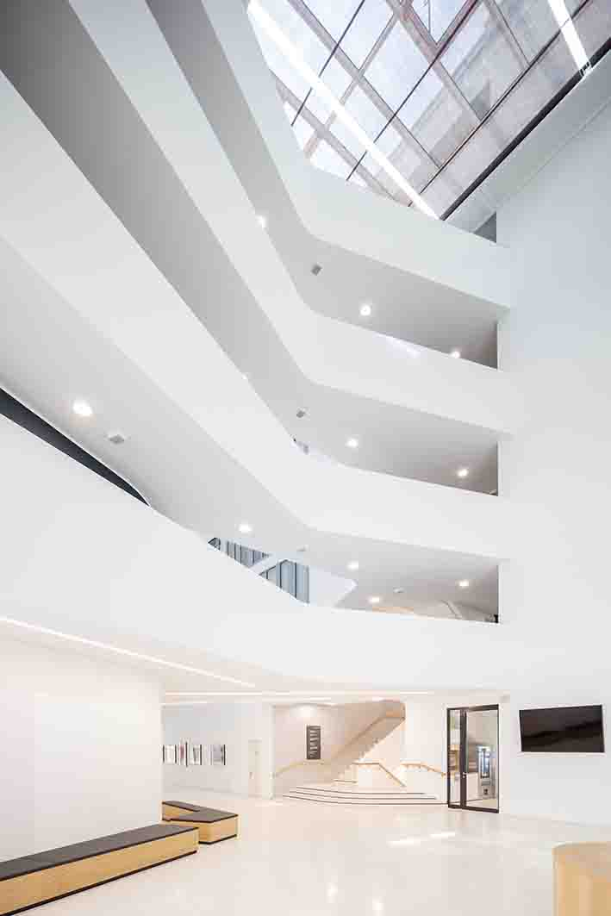

Two entrances provide barrier-free access to the cafeteria: the main entrance has been built as a fire protection door with Powerturn F/R drives and opening buttons on both sides. The entrance at the back of the lift is fitted with a hold-open system with TS 5000 R door closers. Together with another hold-open system as a means of access to the niche with snack and drinks machines set up directly in front of the cafeteria, the catering area forms its own barrier-free fire section.
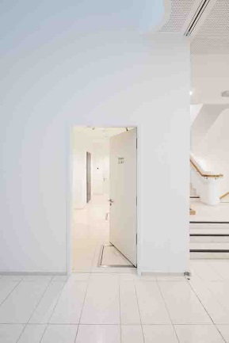
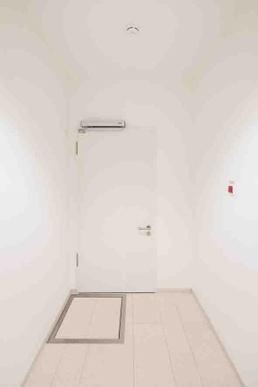

The hold-open systems' fire protection doors which lead to the sanitary facilities are barrier-free and easy to open. The lintel installation that has been chosen here for the TS 5000 RFS free swing door closers makes them very flexible for the door installers. It is easier to retrofit them to other doors than it is the case for door closers installed on the door leaf.

Barrier-free access to upper floors
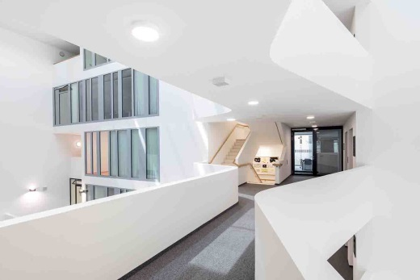
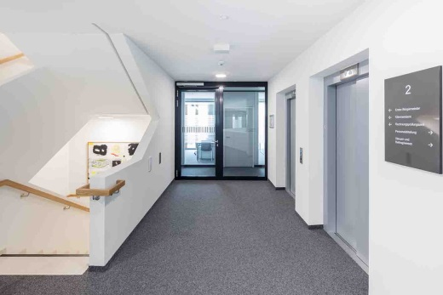
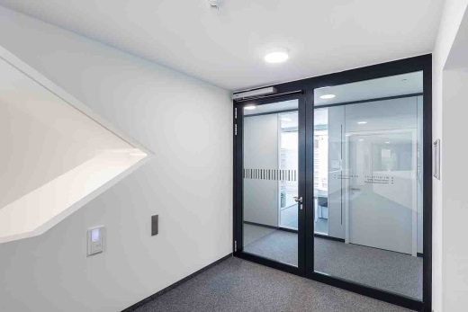

People with restricted mobility use the lift to have barrier-free access to the single-leaf doors that lead to each floor. These doors are fitted with Powerturn F/R drives. On both sides of the doors, opening buttons have been installed. The doors to each storey are time-controlled via the building management system so that, from a set time of day, they can only be opened from the outside by being released after a bell has been rung. The fire protection doors can be easily opened from the inside thanks to the Smart swing function. Secure, safe closing of the door (necessary for the fire protection function) is ensured in all cases.
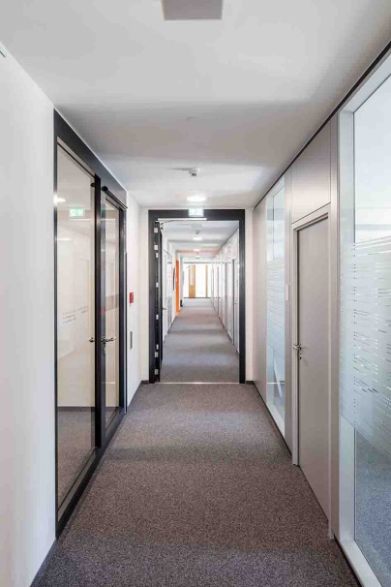
And the barrier-free features continue: on all the fully accessible floors single- and double-leaf hold-open systems with TS 5000 R or R-ISM door closers provide convenience in daytime operation and reliable fire protection. Activated by fire detectors, the doors close if there is a fire and they create fire sections and keep all the escape routes and the respective escape route staircase free of smoke. The staircase can be accessed via single-leaf fire protection doors which provide barrier-free opening with the TS 5000 ECline door closers that have won many prizes.

Fresh air – a secured escape route
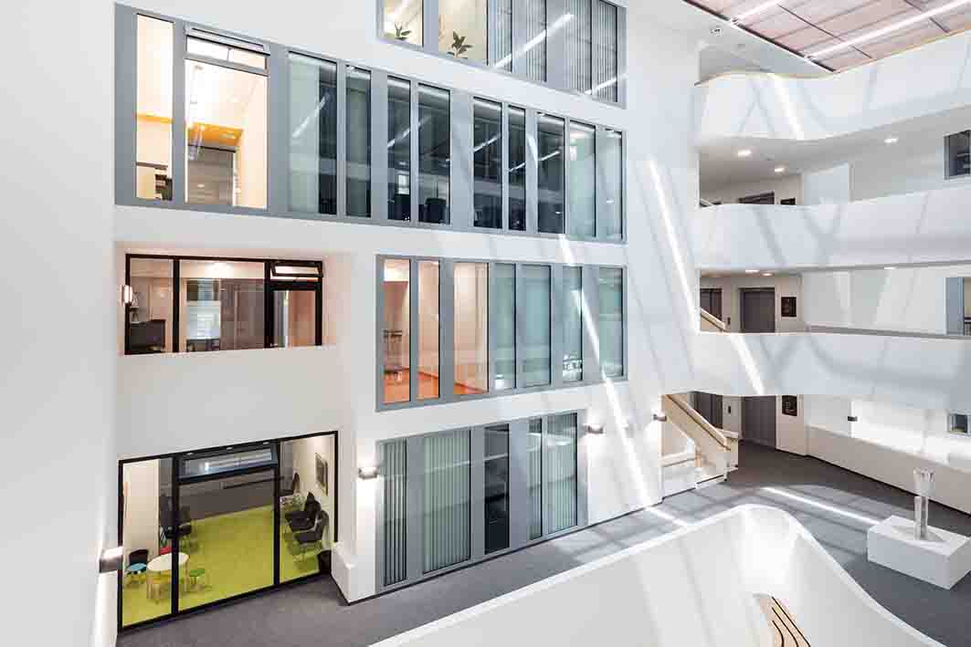
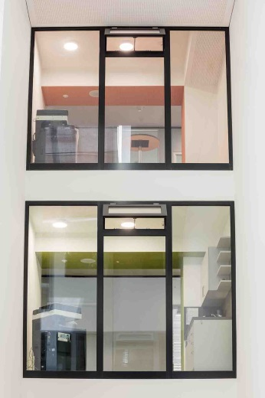

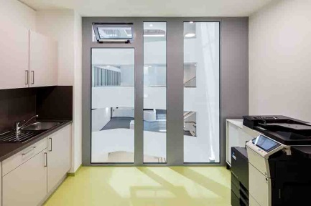

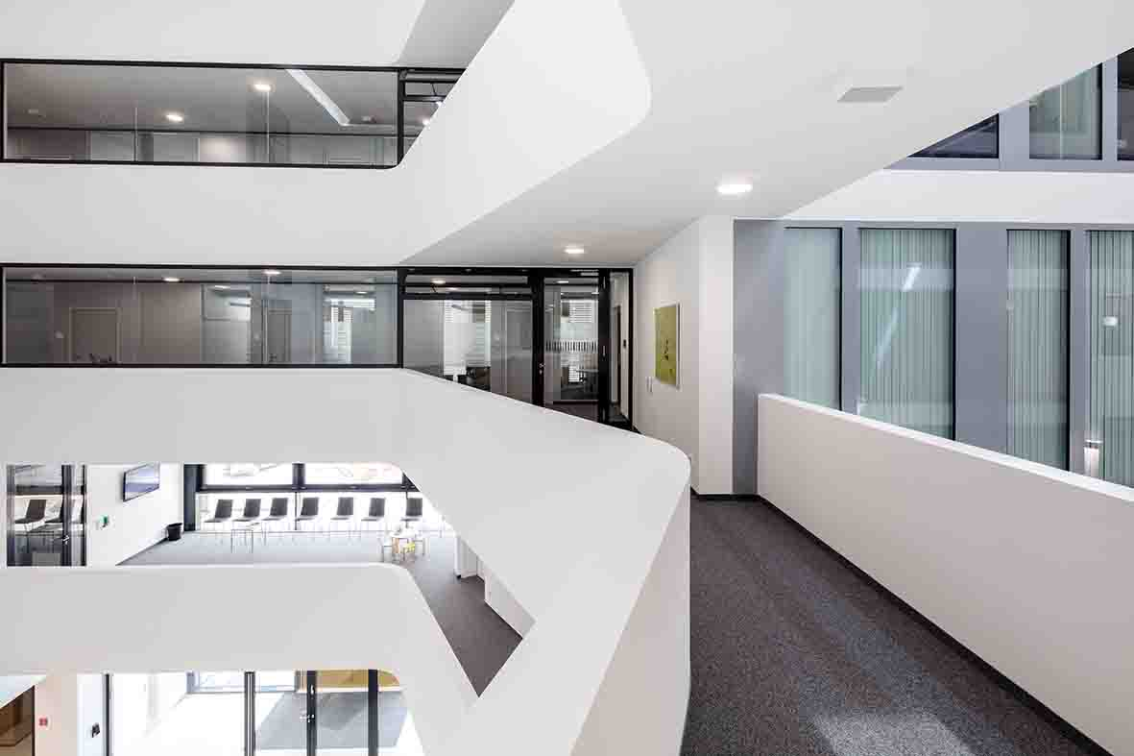

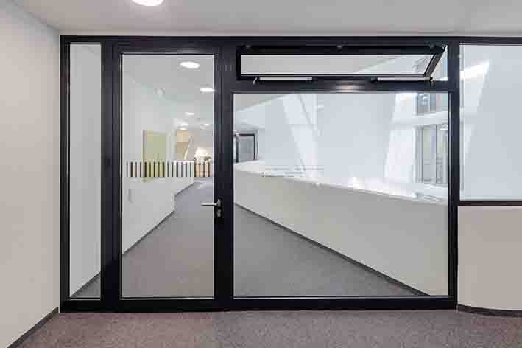

Fresh air guaranteed: automated fanlights with Slimchain and Powerchain window drives

The automated fanlights fitted with Slimchain drives in the interior kitchenettes on each floor and in the corridors provide fresh air from the atrium. However, if smoke or heat builds up, this is precisely what needs to be prevented. If smoke or heat builds up in the atrium, the fanlights are closed via the fire detector system so that fire smoke is kept out of the individual storeys. In order to enable fresh air from the outside to be fed in in the event of a fire so that layers of air with low smoke content can be formed, powerful Powerchain-Syncro chain drives open several large outside windows in the 'Family and Education' waiting area on the first floor. These synchronised power packages with a maximum lift of 1,200 millimetres also enable maximum window opening in less than 60 seconds in the event of a fire. The windows act as a fresh air intake for the atrium so that fire smoke can escape via the large roof window.

The manual door next to this waiting area must fulfil complex functions such as protection from unauthorised access and providing a free passage for fleeing people in the event of danger. As an escape door it gives access to the office corridor which acts as an escape route. It is open during daytime operation, but locked depending on the situation, e.g. when the offices are closed. It can then be accessed by authorised people via the access control system. In an emergency the door can however always be used by anyone in the emergency exit direction because the electric strike for escape routes comes into operation and opens the door via the emergency button in the GEZE TZ 300 emergency exit control unit. The same door solution simultaneously fulfils the same functions next door at the entrance to the corridor to the town treasury.

Overview: GEZE products in the new Leonberg town hall

Foyer:
Three vestibules each with two Powerturn swing door systems
Main entrance: Powerturn swing door drive
Cafeteria entrance facade: Powerturn IS/TS and Powerturn F/R for fire protection doors
Entrance facade to the council chamber: Powerturn F/R-IS for fire section door and emergency exit

Council chamber:
Main entrances: Powerturn F/R-IS/TS for fire protection doors
Additional access and access to the rooms for the political parties: Hold-open systems with TS 5000 R-ISM door closers
Escape doors: TS 5000 door closers
RWA and ventilation windows: Slimchain drives
RWA BUS central control unit MBZ 300 as a control device

Cafeteria:
Main entrance: Powerturn F/R for fire protection doors
Rear entrance: Hold-open system with TS 5000 R door closers

Foyer and cafeteria sanitary facilities:
Hold-open systems with TS 5000 RFS free-swing door closers

Doors to each storey:
Powerturn F/R for fire protection doors
Hold-open systems with TS 5000 R or R-ISM door closers
TS 5000 ECline door closers for manual, barrier-free swing doors

Kitchenettes on each floor / waiting areas on upper storeys / office hallways:
RWA and ventilation windows: Slimchain and Powerchain drives
TZ 300 emergency exit control unit and escape door openers.

